
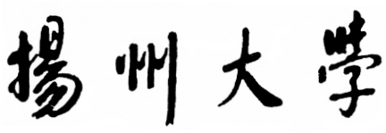

Bachelor's degree thesis

Subject | QUAW-Net: Quality-Aware Weighted Network for Retinal Vessel Segmentation
Name/Student No. | TOMAL MD TALAT MAHMUD  (孟亮)228801146
College | College of Artificial Intelligence and Industrial Software
Major Field | Software Engineering
Supervisor | 陈才扣
Date | 10 May 2026

Abstract
Retinal vessel segmentation is a key fundamental step in computer-aided diagnosis of ocular and systemic diseases. However, existing methods face two major challenges in practical applications: first, there are subjective differences in manual annotations by different experts, making it difficult to ensure annotation consistency; second, segmentation models usually lack the ability of confidence estimation, which limits their reliability in clinical auxiliary decision-making.
To address the above problems, this paper proposes a retinal vessel segmentation network QUAW-Net based on annotation quality-weighted supervision. This method takes Attention U-Net as the backbone network and introduces an Annotation Quality Estimation Module (AQEM). By fusing image content features, annotation distribution patterns and the current prediction results of the model, it adaptively learns the sample-level weights of annotations from each expert, realizing "weighted integration" (i.e., weighted fusion of multi-expert annotations instead of adopting a multi-model integration strategy). Based on the estimated annotation weights, the network uses quality-weighted Dice loss and edge-sensitive loss for training, enabling the supervision signal to dynamically adapt to the differences among annotators. In addition, this paper adopts the Monte Carlo Dropout method to approximate the segmentation uncertainty, generating average segmentation masks and prediction variance maps to provide a reliability reference for clinical decision-making.
Experiments were conducted on the CHASE_DB1 dataset, which contains 28 binocular fundus images (resolution of 999×960 pixels) from 28 subjects (14 healthy people and 14 patients with diabetic retinopathy), and each image was independently annotated by two experts. The training process adopted a patch-based training strategy, combined with a temperature annealing mechanism to gradually optimize the annotation weights: uniform weighting was used in the initial stage, then the AQEM module was activated for high-temperature soft weighting, and finally, the weights converged to stable values through temperature annealing. Experimental results show that the optimal model achieves an average Dice coefficient of 0.7646 (IoU of 0.6297) on the validation set and an average Dice coefficient of 0.7248 (IoU of 0.6131) on the test set, and the prediction uncertainty gradually decreases with the convergence of training.

Keywords: Retinal Blood Vessel Segmentation; annotation quality estimation; boundary-aware loss; uncertainty estimation; Monte Carlo dropout.

摘 要
视网膜血管分割是计算机辅助诊断眼部及全身性疾病的关键基础步骤，然而现有方法在实际应用中面临两大挑战：其一，不同专家的手动标注存在主观差异，导致标注一致性难以保证；其二，分割模型通常缺乏置信度估计能力，限制了其在临床辅助决策中的可靠性。
针对上述问题，本文提出一种基于标注质量加权监督的视网膜血管分割网络 QUAW-Net。该方法以 Attention U-Net 为骨干网络，引入标注质量估计模块（AQEM），通过融合图像内容特征、标注分布模式及模型当前预测结果，自适应地学习各专家标注的样本级权重，实现"加权集成"（即对多专家标注进行加权融合，而非采用多模型集成策略）。基于估计的标注权重，网络采用质量加权 Dice 损失与边缘敏感损失进行训练，使监督信号能够动态适应标注者间的分歧。此外，本文采用蒙特卡洛 Dropout 方法近似估计分割不确定性，生成平均分割掩码及预测方差图，为临床决策提供可靠性参考。
实验在 CHASE_DB1 数据集上进行，该数据集包含 28 名受试者（14 名健康人及 14 名糖尿病性视网膜病变患者）的 28 幅双眼眼底图像（分辨率为 999×960 像素），每幅图像由两位专家独立标注。训练过程采用基于图像块的训练策略，并结合温度退火机制逐步优化标注权重：初期采用均匀加权，随后激活 AQEM 模块进行高温软加权，最后通过温度退火收敛至稳定权重。实验结果表明，最优模型在验证集上的平均 Dice 系数为 0.7646（IoU 为 0.6297），测试集上的平均 Dice 系数为 0.7248（IoU 为 0.6131），且预测不确定性随训练收敛逐渐降低。

关键词： 视网膜血管分割；标注质量估计；边界感知损失；不确定性估计；蒙特卡洛随机失活。

Contents

Abstract I
摘 要 II
Contents III
Chapter 1. Introduction 1
1.1 Subject analysis and research 1
1.1.1 Background 1
1.1.2 Requirements 1
1.2 Worldwide research status 2
1.2.1 Conventional retinal vessel segmentation and open data. 2
1.2.2 Deep learning architectures for vessel segmentation 3
1.2.3 Multi-annotator learning, label uncertainty and uncertainty estimation. 3
1.3 Research objectives 4
1.4 Methodology overview 4
1.5 Main contributions / novelty 6
Chapter 2. System requirements analysis 8
2.1 Overall system analysis 8
2.1.1 System description 8
2.1.2 System functional structure: 8
2.2 System function analysis 9
2.2.1 analysis of the function of user information. 9
2.3 System operation analysis 9
2.3.1 Operating environment preparation 10
Chapter 3 System outlines design. 11
3.1 Design of data flow chart. 11
3.1.1 User request–response data flow 11
3.1.2 Model inference and artifact generation data flow 12
3.2 System module outline design 12
3.3 Algorithm outline design 13
3.3.1 QUAW-Net Backbone Outline 13
3.3.2 QUAW-Net + AQEM integrated outline 14
3.3.3 Uncertainty estimation outline (MC Dropout) 17
Chapter 4 Detailed design and implementation of the system 18
4.1 Implementation Details 18
4.1.1 Environment Setup 18
4.1.2 Implementation Plan 19
4.2 Implementation Process 19
4.2.1 Data Preparation 20
4.2.2 Model Development (QUAW-Net + AQEM + MC Dropout) 21
4.2.3 App Deployment 26
Chapter 5 System Test and Result 28
5.1 Training Progress and Results 28
5.1.1 Training Phases 28
5.1.2 Training Metrics 29
5.2 Module Analysis and Effects 30
5.2.1 AQEM Module 30
5.2.2 Temperature Annealing 30
5.3 Test Set Evaluation 30
5.4 Model prediction and uncertainty heatmap 31
5.5 Discussion 32
Chapter 6 Conclusion 34
Acknowledgement 36
References 37

Chapter 1. Introduction

1.1 Subject analysis and research
The topic of this study is at the crossroads of medical image segmentation, learning with label noise, and uncertainty estimation. The classical supervised segmentation is based on the assumption that there is one correct label of an image. In datasets of retinal vessels, this assumption can be too strong: expert annotations may also disagree systematically (because of different tracing styles) and locally (small vessels, fuzzy boundaries). By training models by considering one annotation to be the absolute truth, it risks learning an annotator-specific bias, and can exhibit unstable behavior upon comparison with another valid annotation style.

In research terms, the problem may be expressed as follows: how to learn a vessel segmentation model which is accurate and robust when it is supervised by a number of, possibly conflicting, annotations, and how to provide an estimate of the uncertainty of its output. In this thesis the strategy is to (1) maintain a high base of segmentation with the help of an encoder-decoder network with attention, (2) learn annotation quality weights directly out of data through an auxiliary module and (3) estimate uncertainty with the help of stochastic inference (dropout sampling). The combination is aimed to make the learning more realistic to the actual clinical labeling conditions and to generate outputs which are more interpretable under the risk-sensitive situations.

1.1.1 Background
Retinal imaging (e.g. fundus photography) is popular due to it being a non-invasive technique with a direct view of microvasculature. The vessel morphology, which includes tortuosity, width change, branching pattern, and density of the vessel, supports screening and monitoring of diseases such as diabetic retinopathy, changes in width, branching patterns and density of the vessel. A high quality vessel map is used as a preprocessing task in many downstream tasks (lesion detection, artery/vein classification, optic disc localization, or disease staging).

Deep learning and especially U-Net-based designs have become the new paradigm in biomedical segmentation because they are capable of learning multi-scale features and even the spatial detail. Attention mechanisms further enhance the performance by enabling the network to pay attention to relevant structures and can ignore background noise. Nevertheless, there are still two limitations that are significant in practice when implementing medicine. And, first, there is uncertainty in labels: labels are costly, subjective, and might differ among experts. Second, model uncertainty is not often reported: even in cases when the model predicted mask appears realistic, clinicians must know the areas, which should be trusted and those, which should be uncertain. The rationale behind this thesis is not only its constraints but also the overall creation of a single framework that would manage these constraints when it comes to training and assessment.

1.1.2 Requirements
The thesis work is informed by a suite of pragmatic and research-based requirements. These requirements specify the result(s) that the system should attain in order to qualify as successful and not just a result of merely training a model.
The system should be able to accommodate multi-annotator learning at the data and supervision level. This implies that it must consume at least two professional masks of the vessel on the image and should not favor one annotation and claim it as the sole truth. It must also facilitate application of field-of-view (FOV) masks in such a way that training and evaluation is done using valid retinal regions and not the black background.
This requirement is stricter than ordinary single-ground-truth retinal vessel segmentation. Because AQEM learns relative annotation quality, each eligible training image should provide at least two independent expert vessel masks; otherwise, annotator-specific reliability cannot be estimated and the method degenerates into conventional single-label supervision. Therefore, dataset eligibility, rather than only dataset size, is a core experimental constraint in this thesis.

At the methodology level, the approach should (i) offer a competitive segmentation initial criterion using well-developed architecture (an Attention U-Net backbone), (ii) provide a mechanism to model annotation quality in such a way that it is feasible with standard deep learning tooling (MC Dropout), and (iii) uncertainty estimation should be provided in such a way that it is practical to implement with standard deep learning tooling (MC Dropout), and produces an uncertainty map aligned with the segmentation output.

On the engineering/experimentation level, the pipeline should be end-to-end and reproducible: consistent preprocessing across training/validation/testing/inference, stable evaluation metrics (Dice/IoU at minimum), and an implementable training schedule that does not exhibit unstable behavior due to the introduction of annotation weighting. High resolution retinal images combined with thin vessels mean that the training strategy must be computationally feasible too, which implies that patch-based sampling is necessary, to fit the memory resources, and yet to expose the model to vessel-rich patches.

Lastly, the assessment has to be significant within the multi-annotator framework. A report of results against each annotator on a case-by-case basis and as an average and the thesis should discuss generalization to a held-out test split. Besides accuracy measures, uncertainty statistics ought to be reported to show that the model provides a sense of uncertainty that becomes sensibly decreasing as the training converges.

1.2 Worldwide research status

1.2.1 Conventional retinal vessel segmentation and open data.
Prior to the conquest of deep learning, retinal vessel extraction was typically formulated as a pixel-wise classification or ridge/line detection problem, on hand-crafted features and classical classifiers. One widely cited and representative method is by Staal et al. (2004), Ridge-based vessel segmentation in color images of the retina which used a ridge-based approach and became a standard reference point partly because it agreed with popular benchmarking practices on fundus data.

Feature-engineering + supervised learning continued to be extremely powerful over the years. A popular example of this kind that employed a bank of Gabor filters and a supervised classification to segment vessels is Soares et al. (2006), Retinal vessel segmentation using the 2-D Gabor wavelet and supervised classification. These classical pipelines brought into focus the main difficulties which are still relevant today as strong imbalance of classes (thin vessels vs. background), low contrast, central vessel reflex, and large difference in appearance across the cameras/patients.

In order to ensure evaluation is reproducible, common datasets and generic protocols were brought into key focus. Besides DRIVE/STARE, CHASE_DB1 was specifically described as a subset of retinal pictures of multi-ethnic children in the Child Heart and Health Study in England (CHASE).^{[18]} Later work further validated CHASE_DB1, including pediatric-specific challenges, for example, Fraz et al. (2014), “Delineation of blood vessels in pediatric retinal images using decision trees-based ensemble classification”.

1.2.2 Deep learning architectures for vessel segmentation
The current research in vessel segmentation mostly traces back to the overall development of semantic segmentation. Long, Shelhamer, and Darrell (2015), Fully Convolutional Networks for Semantic Segmentation, introduced an end-to-end fully convolutional paradigm, which gives birth to dense pixel predictions, providing motivation to designs of biomedical imaging in an encoder-decoder style.

Ronneberger, Fischer, and Brox (2015), U-Net: Convolutional Networks to Biomedical Image Segmentation became a standard architecture in medical imaging that in particular adopted the skip connections that preserve spatial detail, specifically a very good fit to thin elongated structures such as vessels. Quickly followed retinal-specific deep models, such as Maninis et al. (2016), “Deep Retinal Image Understanding, proposed a CNN-based architecture to segment retinal vessels and optic disc in multiple public datasets and achieved impressive results.

With maturation of architectures, the focus and structural priors were added to enhance the sensibilities to small vessels and inhibit irrelevant background. Oktay et al. (2018), Attention U-Net: Learning Where to Look to Find the Pancreas, described attention gates, which could be embedded in U-Net-like models, and implemented since. The other direction is that it exploits the redundancy of the vascular networks: Li and others (2020), IterNet: Retinal Image Segmentation by exploiting Structural Redundancy in Vessel Networks, use repeated sub modules based on U-Net to progressively refine vessel predictions by exploiting structural redundancy in the vessel networks.

Loss design too improved to deal with imbalance of classes and accuracy of boundaries. Kervadec et al. (2019), Boundary loss: highly unbalanced segmentation, (extended versions of the paper in 2021 as the Journal of Medical Image Analysis) proposed a contour-based loss that supplements region-based losses (e.g., Dice/CE) and conceptually aligns with the aim of improving vessel boundary delineation.

1.2.3 Multi-annotator learning, label uncertainty and uncertainty estimation.
A recurring practical problem in medical segmentation is that even ground truth is not often sure: even within a single rater over time, there is often no consensus. Classical label-fusion models explicitly model rater reliability; a canonical reference is Warfield, Zou, and Wells (2004), “Simultaneous truth and performance level estimation (STAPLE): an algorithm to estimate image segmentation canonical reference, which estimates both a probabilistic latent truth, and per-rater performance parametric choices, via an EM procedure.

As the deep learning model emerged, similar concepts re-emerged as learning from crowds or multi-annotator supervision where the model learns annotator reliability/skill instead of the one correct label. Examples of such references are Rodrigues and Pereira (2018), Deep learning from crowds, which discusses learning the model parameters jointly with the annotator reliabilities and provide a trainable crowd layer to enable end-to-end learning with multiple noisy annotators.

Quantification of uncertainty has to do with that: in case the labels are noisy or ambiguous then ideally the models should provide calibrated confidence estimates rather than hard masks. Popularized Monte Carlo Dropout as a practical approximate Bayesian model to compute predictive uncertainty using standard neural networks. Monte Carlo Dropout is a straightforward technique that can be easily used by researchers and practitioners when dealing with neural networks. Further elucidating epistemic vs. aleatoric uncertainty, Kendall and Gal (2017), What Uncertainties Do We Need in Bayesian Deep Learning in Computer Vision, further clarified uncertainty-sensitive formulations of vision tasks, such as segmentation. Uncertainty maps are of particular use in segmenting retinal vessels, since there is both a tendency to localise prediction errors, and there is a tendency to localise annotator disagreement.

1.3 Research objectives
- Design an effective retinal vessel segmentation system of fundus images that can learn in the presence of multiple manually annotations per image and does not assume that they are as reliable as each other.
- Design a quality conscious label-weighting strategy (per image/patch, per annotator) that estimates the annotator reliability based on the input image and annotation environment and uses these weights to create a more robust target of training.
- Enhance restoration of thin vessels and boundaries when there is strong class imbalance by combining region-based overlap supervision (e.g. Dice-style) with supervision at boundaries (distances/boundaries-aware loss concepts).
- As an addition to the inference pipeline, to generate uncertainty maps together with vessel masks, to highlight the uncertain areas and potential annotation-disagreement regions, the uncertainty estimation should be incorporated into the inference pipeline (e.g., Monte Carlo Dropout).
- The tasks should be completed: Build a full, reproducible training and evaluation pipeline with the CHASE_DB1 dataset with two manual labels (including preprocessing and augmentation/patch sampling).
- Generalization and robustness: Evaluate generalization and robustness comparing a validation vs. test performance, and analyzing how the level of uncertainty is correlated with errors and/or difficult anatomical regions (e.g., thin vessels, low-contrast areas).

1.4 Methodology overview
The current study will propose a useful pipeline of segmentation of the retinal vessels, which will take into consideration two common constraints to the real-world medical image annotation: (1) the quality of segmentation will be strongly dependent on the differences in the quality of the images (illumination, low contrast, thin vessels), and (2) manual annotations might be inconsistent among the various annotators, leading to labeling disagreement and uncertainty in the so-called ground truth. The general methodology is based on a progressive roadmap to achieve strong feature representation, a good quality of the produced results, and the ability to interpret the result: baseline U-Net segmentation to better strong feature representation, good quality of the obtained results, and the ability to interpret the result.

(1) Baseline segmentation using U-Net
The classical U-Net architecture is the starting point of the method, which has an encoder-decoder architecture and skip connections, making it a popular choice of the architecture in biomedical segmentation. The encoder gradually recovers high-level semantics (e.g., vessel-like patterns), whereas the decoder recovers the spatial resolution to classify pixels at a pixel level. skip connections mediate between low-level detail (that of a fuse) and high-level semantics (that of a vessel), which is especially useful in the case of retinal vessels because vessel structures comprise numerous fine branches which are easily lost due to downsampling. The baseline U-Net thus offers a good reference point on which to train vessel segmentation; but when the labels that the model is being trained on cannot be consistently annotated across different annotators, then training the model directly against a single annotation may cause biased learning or unstable convergence.
(2) QUAW-Net enhancements of vessel feature learning
The baseline U-Net is improved and used as the backbone of the vessel topology segmentation in challenging imaging conditions with the resulting QUAW-Net. The point is that the feature fusion and spatial selectivity of the network should be enhanced to provide the model with focusing on vessel-relevant areas and eliminating the background noise. Moreover, dropout is incorporated in the decoder pathway in a way that they can be enabled at the inference time to estimate uncertainty. These regularization and architecture choices are meant to enhance robustness in situations where vessels are faint, thin or partially obscured, and to enable uncertainty-aware prediction.
AQEM (3): quality-sensitive weighting of multi-annotator disagreement
One of the key methodological tomes is the Annotation Quality Estimation Module (AQEM). Manual segmentations in multi-annotator systems can be inconsistent with each other, particularly around thin vessels and low-contrast parts of an object, and on pixels at edges. In treating all annotations in the same way, noise may be propagated into the learnt model. AQEM works around this by providing an approximation of a relative quality score of any annotator label (or each annotation source) given the input image and the previous model prediction. These quality scores are then passed through a temperature controlled softmax function, to convert these values into normalized weights. Each time this is repeated, the final signal of supervision is created, comprising the multiple annotations, using these adaptive weights, such that higher quality labels (more consistent) contribute more, and lower quality labels (noisy, or inconsistent) utilize less. This will enhance the stability of learning and minimize the adverse effect of an annotator disagreement.
Note: MC Dropout uncertainty estimation to be interpretable.
Segmentation uncertainty is also significant even when there is good architecture, quality-conscious training since retinal images have ambiguous areas: thin vessels can be virtually as close to noise as is feasible, and delimitations can be a problem even in the case of expert delimiters. Thus, the methodology will involve MC Dropout that will measure uncertainty at the time of inference. To test the trained model, the model is tested on the same input several times with dropout turned on generating a number of stochastic predictions. The overall vessel probability map is the final prediction, the mean prediction, and the variance between the predictions gives a pixel wise uncertainty estimation. Areas where the variance is large mean that the model is not as certain and advises the user to be more cautious when looking at such areas. This visualization of the uncertainties enhances better transparency, and the system becomes more acceptable to educational demonstration and research discussion.
(5) Cloud GPU training and checkpoint transfer to the application
To optimize experimentation and training, the model training was run on a cloud environment with the use of a GPU. The checkpoint file the best-performing model weights was saved after training. This checkpoint was subsequently moved to the local machine and loaded by the inference application, which is a web-based application. It starts by loading the saved last checkpoint upon start, and then proceeds to perform preprocessing and patch-based inference on the binary segmentation mask and the status quo high-contrast uncertainty heatmap that it generates upon presentation.
(6) Pipeline deployment- reproducible demonstration
To make sure that the method can be presented in a reliable manner, before the teachers, the final system is launched as a lightweight Browser/Server application. The user uploads an image via a browser and the backend loads the trained checkpoint, executes preprocessing and segmentation inference and generates outputs of visualization and key numerical indicators (e.g., inference time, vessel area ratio, uncertainty summary). This design describes a complete and reproducible research-to-application pipeline (both methodologically novel and practically usable), including research (cloud GPU training in notebook), and application (local inference using the exported checkpoint).

1.5 Main contributions / novelty
Quality-sensitive multi-annotator learning with AQEM: Introduced a quality estimation system in annotation based on multi-annotators with AQEM: It was demonstrated that a quality estimation mechanism is introduced, which uses adaptive weights on the labels of various annotators, reducing the adverse effect of label disagreement and enhancing training resilience in hard vessel areas.
- A quality-aware annotation-weighted supervision mechanism is proposed to handle multi-expert retinal vessel annotations. The weighting operation is performed at the supervision level by dynamically assigning quality-based weights to expert annotations through AQEM, rather than by combining multiple independently trained model backbones.
- Based on the U-Net family with architectural/regularization options that are more fit to preserve thin vessels and robustly fuse features under illumination/contrast variability.
- The use of MC Dropout variance to provide uncertainty heatmaps to interpret the results demonstrated uncertain performance due to the decoder’s overconfidence and the dominant error mode of overfitting.
- End to end reproducible pipeline: (a) implemented a complete workflow of, (b) cloud GPU notebook training to (c) checkpoint export and (d) deployed a lightweight local web server loading the checkpoint to make inferences.
- Designed the application to generate and present three clear outputs (original image, binary mask, standalone uncertainty heatmap) and minimal quantitative measures, allowing one to easily and reliably demonstrate theses defense through straightforward demonstrations.

Chapter 2. System requirements analysis

2.1 Overall system analysis
This project offers a demonstration system of a lightweight QUAW-Net retinal vessel segmentation demonstration system. It learns end-to-end prediction of a vessel segmentation mask/overlay of a retinal fundus image to: (1) a vessel segmentation mask/overlay and (2) an uncertainty heatmap based on Monte Carlo (MC) Dropout variance.

2.1.1 System description
System assumes a standard architecture of a Browser/Server (B/S) system. The frontend is just a static web page running in a browser and enables the user to upload image or select a demo sample, choose an inference mode (fast/accurate) and see the results. The backend is a FastAPI server which loads the QUAW-Net checkpoint, performs standardised preprocessing (green channel extraction, illumination correction, CLAHE, percentile normalisation), inference with sliding-window MC Dropout, to produce a mean segmentation probabilistic map and a pixel-wise variance map, and then exports a variety of result images (original, raw/preprocessed, binary mask, overlay, uncertainty overlay). Quantitative summaries, such as the vessel area ratio and the uncertainty mean / P95 are also computed at the backend and reported when the field-of-view (FOV) mask can be estimated or when it is not, the statistics are reported on the full image instead.
Table 2.1 Functional Requirements of the QUAW-Net System
Function | Description
Status display of model | Display whether the checkpoint is loaded or not and report runtime config: device, patch/stride, dropout, threshold, and MC samples.
Upload-based inference | Upload a retinal image and execute vessel segmentation and uncertainty estimation.
Result visualization | Display binary mask, segmentation overlay, and uncertainty heat map overlay to the user.
Quantitative summary | Calculate and present vessel area ratio, statistics on uncertainty such as mean/P95, processing time, and image size.
Table 2.2 Non-functional Requirements of the QUAW-Net System
Category Requirement | Design Measure
Usability | Very few steps are required to make predictions. The interface provides clear feedback to users through a simple single-page UI, a disabled run button until a file is selected, status/error text, and a model status badge.
Portability | The system can run as a local program on most operating systems using Python and FastAPI, and it does not require a database.
Performance | The system supports a “fast vs. accurate” trade-off by providing two modes. The fast mode uses fewer MC samples, while the accurate mode uses more MC samples.
Reliability | The system handles invalid inputs and missing checkpoints safely by checking content type, limiting file size, and returning informative error messages.
Maintainability | The system follows distinct module separation, with separate logic for settings, preprocessing, inference, model, API, and UI components.

2.1.2 System functional structure:

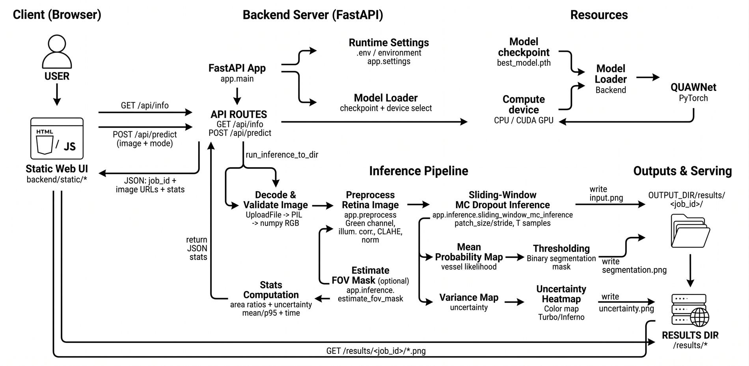
Figure 2.1 System Function Structure

2.2 System function analysis
The project offers end-to-end retinal vessel segmentation service that is provided with a fundus image and will perform preprocessing and deep-learning inference and return (1) a binary vessel mask, (2) an uncertainty heatmap based on MC Dropout variance, and (3) quantitative metrics to support the interpretation of results. In practice, the system is designed into a user-friendly web interface, an API service (backend) and a trained QUAW-Net model component, an inference pipeline (preprocessing + sliding-window prediction), and an output management module that stores and delivers generated results.

2.2.1 analysis of the function of user information.
The functions on the user interface are composed in such a way as to simplify interactions, yet offer the user the knowledge necessary to facilitate a research review:
- Image input: The user uploads a retinal fundus image with the help of the web page. It checks and confirms that the file uploaded is an image and then proceeds to process the files.
- Inference mode selection: Mode of inference can be selected to be Fast or to be Accurate. The number of Monte Carlo samples to apply in the inference process is controlled by this choice and trades off between speed and stability in uncertainty estimation.
- Result visualization: After processing, the interface will show three outputs: the original image and the predicted binary vessel segmentation mask as well as a standalone uncertainty heatmap, i.e., the higher the intensity, the more uncertain the model.
- Key metrics display: The system will display numerical values of inference time, image size, ratio of vessel and rest ratio (full image or within the estimated field-of-view), and statistics of uncertainties (mean and 95th percentile). By aiding users in comparing runs, assessing the prediction confidence, and recording the results of the experiment.

2.3 System operation analysis
This section outlines the practical operating procedure of the retinal vessel segmentation system, such as environment preparation system, parameter setting system, service beginning system, inference being system, and result management system. The objective is to make sure that it is possible to run the system reproducibly and can be demonstrated to run smoothly during the thesis defense.

2.3.1 Operating environment preparation
(1) Hardware and OS requirements
- A Windows PC will be adequate to demonstrate. By default, the system supports CPU inference, and using a CUDA-capable GPU plus having PyTorch installed with CUDA support could be used to increase inference speed.
- Recommended memory: Over 8 GB RAM (higher is always good to increase inference speed).
(2) Software requirements
- Python environment Python 3.12 (or 3.11) is recommended due to avoiding binary compatibility problems of scientific libraries.
- python dependencies: FastAPI/uvicorn to provide a web service, PyTorch to find model predictions, NumPy to do basic arithmetic, OpenCV and Pillow to provide image I/O and visualisation.
(3) Creation of virtual environment and dependency installations.
- Make a separate virtual setting behind the scenes.
- Install all dependencies with the given requirements.txt to be sure that the version of certain dependencies is the same between different machines.

Chapter 3 System outlines design.
In this chapter, the outline design of the retina vessel segmentation system is presented in the context of data organization and the general work logic of the system. A Browser/Server architecture is adopted in the system. The user interface is the interaction of the user via a browser page, and the service on the other end loads a trained model checkpoint, performs preprocessing and patch-based inference, generation of three visualization outputs (original image, binary segmentation mask, and standalone uncertainty heatmap), and returns both result URLs and quantitative statistics.

3.1 Design of data flow chart
The system data flow can be defined as a closed circle of the input into the system, processing by the system, output of the system, and visualization of the understanding of the human input into the system. The input is a retinal fundus image which has been uploaded by the user. The basic processing consists of preprocessing, sliding-window segmentation, and MC Dropout uncertainty estimation. They are stored on files and are alluded to using the direct URLs so that the browser can display the results directly. Moreover, a statistics object is also returned to facilitate quantitative interpretation when presenting.

3.1.1 User request–response data flow
This sub-section explains the data flow, which is transformed through the user interaction until the system responds, with the attention being in the Web layer.
(1) User action and input formation
- The user clicks on a system page, open in a browser, and then selects one of the local retinal fundus images.
- The user chooses inference mode: Fast (a fewer MC samples) or Accurate (more MC samples).
- The browser will assemble a request that will consist of: the file that has been uploaded that is an image file and the mode that was selected.
(2) Backend request-to-server and validation.
- The request is sent to the backend which ensures that the content uploaded is an image and that it is not larger than this maximum allowed file size.
- The error message of the backend is a clear error message whereby inference cannot continue taking place.
(3) Response content and front end rendering.
- Upon inference, the backend will construct a response which includes:
  - a special job identifier,
  - The URLs of the three resulting images ( Original / Segmentation mask / Uncertainty heatmap ) are placed.
  - a collection of meaningful numbers (e.g., inference time, MC samples, vessel area ratio, uncertainty summary).
- The way the browser works is as follows: the page is loaded with the result of the scanned page; the result of the scanned page is an image of the page scanned, and the statistics table fills up with the result of the scanned page, which is an image of the page scanned.

3.1.2 Model inference and artifact generation data flow
The following subsection explains the internal data flow within the backend, algorithmic processing and file outputs.
(1) Image processing and decoding.
- The backend decodes the uploaded image to an RGB array.
- The preprocessing stage transforms the image into a normalized grayscale image which is appropriate to perform vessel segmentation (including illumination normalization and contrast enhancement).
- The system optionally computes statistics within the field-of-view (FOV) region by estimating this region.
(2) Sliding-window prediction (segmentation)
- Since the retinal images can be of high-resolution, the system employs patch-based inference.
- the pre-processed image is padded to fit the patch constraints.
- patches are picked with a constant patch size and stride.
- a patch is then modeled back through the model to get predictions of the probability of vessels.
- overlapping areas are combined together to give the complete-image probability map.
(3) MC Dropout uncertainty estimation.
- To quantify the uncertainty, the system allows dropout layers during inference and re-runs the forward pass (MC samples).
- The average prediction of MC samples is the last segmentation probability map.
- The MC-sample variance is employed as a pixel-wise uncertainty map with a larger variance of the samples indicating less confidence.
(4) Strategy of generating output and saving strategy.
- The threshold on the probability map is used to produce a binary segmentation mask (output image 2).
- The uncertainty variance map is then normalized through a robust approach (FOV-aware percentiles and contrast boosting) and transformed into an un-blended heatmap of continuous colormap (output image 3), which is saved as a standalone heatmap (not blended with the original image).
- The system stores the three outputs in a special job directory, and makes them accessible via fixed URLs to be visualized in a browser. This design does not transmit the large image data several times and enhances responsiveness.

3.2 System module outline design
A clean and presentation-friendly pipeline is supported by the system modules being organized in a manner that supports the pipeline.
(1) Presentation layer (Browser UI)
- Gives the bare minimum interface to either upload an image or to select a mode.
- Shows three outputs clearly in a logical sequence: Original image → Segmentation mask → Uncertainty heatmap.
- Displays important numerical data to aid in the explanation without saturating the audience.
(2) Service layer (Backend API)
- Offers a status interface to check the runtime configuration and the loading of the models.
- Gives an inference interface to accept images and give result URLs and statistics.
- Makes crude exception handling so as to avoid failures in the live demonstrations.
(3) layer Algorithm (Preprocess + Inference + Uncertainty)
- Preprocessing module: normalizes the input images to enhance robustness.
- Inference module: does patch-based segmentation and uncertainty estimation.
- Post-processing module: creates the binary mask and high-contrast standalone uncertainty heatmap.
(4) Output management module
- Creates inference artifacts per job to aid the ability to trace as well as to make easy comparisons across various images or modes.
- Adopts a standardized naming scheme to the files of the result, allowing them to be easily retrieved and displayed.

3.3 Algorithm outline design
Here the algorithm-level design of the proposed system is presented. The algorithm is divided into three sections namely (1) a baseline U-Net segmentation backbone model encoder-decoder, (2) an improved QUAW-Net segmentation backbone model encoder-decoder, as well as (3) MC Dropout-based uncertainty estimation (inference stage) to generate an interpretable uncertainty heatmap.

3.3.1 QUAW-Net Backbone Outline
The adopted vessel segmentation backbone takes an encoder-decoder architecture that is based on an Attention U-Net architecture. The network is trained to produce hierarchical retinal vessel features of a single-channel retinal image patch which has already been preprocessed. This backbone has attention-gated skip connections and decoder dropout, which is more appropriate in terms of thin retinal vessel segmentation and uncertainty-aware inference.

The input to the network is a preprocessed retinal image patch $x∈R1×H×W$. The encoder consists of four convolutional blocks: E1, E2, E3, E4, with feature channels of 64, 128, 256, and 512, respectively. Between encoder blocks, 2×2 max-pooling is used to reduce spatial resolution and enlarge the receptive field. Therefore, the encoder progressively transforms the input image into deeper semantic feature representations while preserving multi-scale vessel information.

The decoder has three stages of upsampling: D4, D3 and D2. The deepest encoder output E4 is initially upsampled and added to the encoder feature corresponding to it E3. The skip features are not directly concatenated, in contrast to a regular U-Net. Rather, attention gates have been used prior to concatenation. These attention gates are used to refine the encoder features, by inhibiting irrelevant background responses and enhancing vessel related spatial information. The attention-guided skip connections are organized as E3→D4, E2→D3, and E1→D2.
Dropout2d is used after each decoder convolutional block. This dropout layer is used in two ways: when training it is used to regularize the network, and when performing inference it is used to estimate uncertainty by using Monte Carlo Dropout. During normal segmentation, the final decoder output is passed through a 1×1 convolution followed by a sigmoid activation function, generating the vessel probability map $\hat{Y}∈{\left[0,1\right]}^{1×H×W}$. Finally, a threshold is applied to the probability map to obtain the binary vessel segmentation mask.

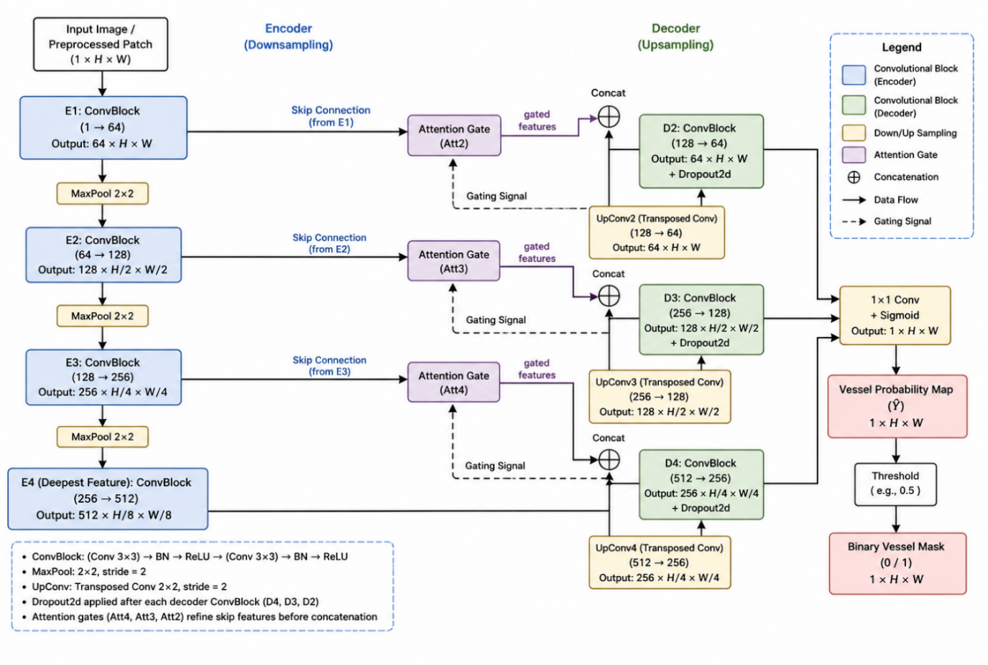
Figure 3.3 QUAW-Net Backbone Block Diagram

3.3.2 QUAW-Net + AQEM integrated outline
The proposed method extends the basic U-Net segmentation framework to improve robustness under complex retinal imaging conditions and multi-annotator label disagreement. The segmentation backbone, referred to as QUAW-Net (Quality-Aware Weighted Network), follows an Attention U-Net-style encoder–decoder structure. In this thesis, the term “quality-aware weighted learning” refers to the adaptive quality-weighted aggregation of multiple expert annotations during supervision, rather than a combination of multiple independently trained backbone networks. It improves vessel feature learning through attention-guided skip connections and decoder regularization. In addition, an Annotation Quality Estimation Module (AQEM) is integrated during training to estimate the relative reliability of multiple expert annotations and assign adaptive supervision weights.
(1) QUAW-Net segmentation backbone (outline)
The structure of the QUAW-Net backbone is that of encoder and decoder. The encoder computes hierarchical vessel as well as global features off of the preprocessed patch of the retina and the decoder in turn progressively reconstitutes the spatial resolution in order to produce a pixel-wise probability map of the vessel. Allocating features not directly produced by the encoder is refined with attention gates and afterwards concatenated with decoder features. This aids the model to lock out irrelevant background details and concentrate more on the vessel structures, particularly on thin vessels and low-contrast vessel edges.

With four convolutional blocks in the encoder, feature channel sizes of 64, 128, 256, and 512. The three-step upsampling stages in the decoder include attention-gated skip connections as (E3), (E2), and (E1). dropout2d goes after decoder blocks to allow the trained model to also support Monte Carlo Dropout during inference to estimate the uncertainty. The last output layer will be convolved with a (1 x 1) convolution and a sigmoid activation function to obtain the vessel probability map:

$\begin{aligned}\hat{Y}=f_{θ}\left(x\right),\hat{Y}∈{\left[0,1\right]}^{1×H×W}\#\left(3.1\right)\end{aligned}$

(2) AQEM module of multi-annotator learning
The CHASE_DB1 dataset consists of a retinal image of every retinal image with two expert vessel annotations. Overall the collection of annotations of a single image can be expressed as:
$\begin{aligned}{\left\{Y^{\left(k\right)}\right\}}_{k=1 }^{K}\#\left(3.2\right)\end{aligned}$
with (K) the number of annotators and (Y(k)) the vessel mask of the (k) annotator. Rather than just believing that all annotations are equally reliable, AQEM approximates the level of quality of each annotation. This is to make higher training significance on more consistent with the picture facts and the existing vessel prediction of the model annotations, which are noisier. The input image patch, the annotation mask corresponding to the annotation mask, and the prediction of the current model all undergo this input imaging, the corresponding annotation mask, and the current model prediction respectively. The model prediction is a detached priority in the implementation before being utilized by AQEM to prevent unstable feedback in training. Hence, the AQEM input of an annotator (k) can be expressed as:
$\begin{aligned}A_{k}=\text{Concat}\left(x,\hat{Y_{detach}},Y^{\left(k\right)}\right)\#\left(3.3\right)\end{aligned}$
where (A k ) is the AQEM input tensor to the (k -th) annotator, (x ) is the preprocessed image patch, (hat Y detach ) is the detached prediction map, and ( Y k ) is the corresponding annotator mask. Quality logit on each annotator produced by AQEM:
$\begin{aligned}q_{k}=g_{ϕ}\left(A_{k}\right)\#\left(3.4\right)\end{aligned}$
where (gphi point)) the AQEM network and (qk) the quality logit of annotator (k). The quality logits are transformed to normalized annotator weights with a temperature-scaled softmax function:
$\begin{aligned}w_{k}=\frac{exp\left(q_{k}\text{/}τ\right)}{\sum_{j=1}^{K}{exp\left(q_{j}\text{/}τ\right)}}\#\left(3.5\right)\end{aligned}$
The weights satisfy:
$\begin{aligned}\sum_{k=1}^{K}{w_{k}}=1\#\left(3.6\right)\end{aligned}$
where it is seen that beside the temperature parameter is the parameter of temperature (tau). A higher temperature will give smoother and more uniform weights and the reverse is also true.

(3) Quality-weighted training objective

The segmentation loss is calculated with respect to each annotator during training, and with respect to a single annotator during training. The segmentation goal which is used in this thesis is a Dice-based region loss along with a boundary sensitive BCE loss. The loss of the (k)-th annotator is given by:
$\begin{aligned}L_{k}=λ_{seg}L_{Dice}\left(P,Y^{\left(k\right)}\right)+λ_{bd}L_{BoundaryBCE}\left(P,Y^{\left(k\right)}\right)\#\left(3.7\right)\end{aligned}$
where $\left(L_{Dice}\right)$ is the overlap between the prediction and the annotation on the vessel, $\left(L_{BoundaryBCE}\right)$ is a boundary-sensitive part of the vessel, and denotes the contribution made by the two loss terms. The loss received by the quality-weighted final loss is computed as:
$\begin{aligned}L_{QW}=\sum_{k=1}^{K}{w_{k}}L_{k}\#\left(3.8\right)\end{aligned}$
In the case of the CHASE_DB1 dataset using two annotators, this is:

$\begin{aligned}L_{QW}=w_{1}L_{1}+w_{2}L_{2}\#\left(3.9\right)\end{aligned}$

This weighted supervision enables QUAW-Net to learn with multiple annotations without considering all expert masks equally trustworthy. This causes the model to be capable of adapting to annotation error and learn a stronger vessel representation particularly in ambiguous areas like thin vessels, low contrast areas, and vessel boundaries.

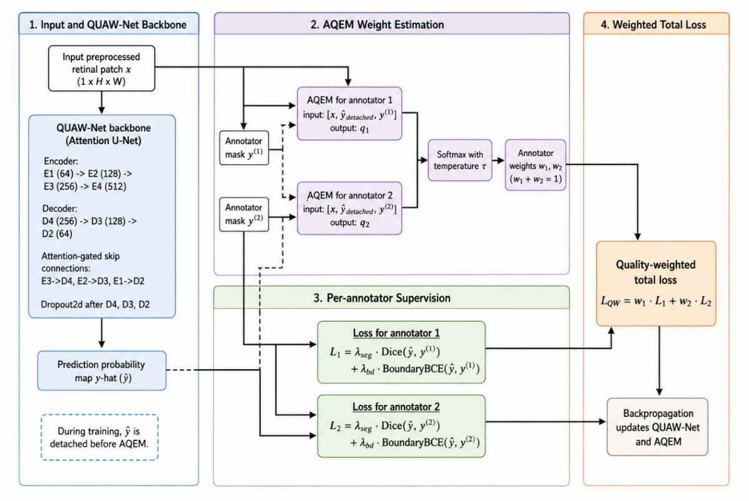
Figure 3.4 QUAW-Net + AQEM Integrated Training Block Diagram

3.3.3 Uncertainty estimation outline (MC Dropout)
To improve interpretability, the system estimates prediction uncertainty using Monte Carlo Dropout (MC Dropout). The key idea is to keep dropout active during inference and run multiple stochastic forward passes on the same input. This produces a distribution of predictions rather than a single deterministic output.
Let ${\hat{Y}}_{t}$ denote the prediction from the $t$-th stochastic forward pass ($t=1,…,T$). Then:
Mean prediction (final segmentation probability):
$\begin{aligned}\text{μ=}\frac{\text{1}}{\text{T}}\sum_{\text{t=1}}^{\text{T}}{{\text{p}}^{\left(\text{t}\right)}}\#\left(3.10\right)\end{aligned}$
Pixel-wise uncertainty (variance map):
$\begin{aligned}σ^{2}=Var\left({\left\{p^{\left(t\right)}\right\}}_{t=1}^{T}\right)\#\left(3.11\right)\end{aligned}$
The mean map $μ$ is thresholded to obtain the binary vessel mask. The variance map $σ^{2}$ is converted into a standalone continuous heatmap (with robust normalization and contrast enhancement) for visualization. Higher variance indicates lower confidence or ambiguous regions, which often correspond to thin vessels, low-contrast areas, and boundary pixels.

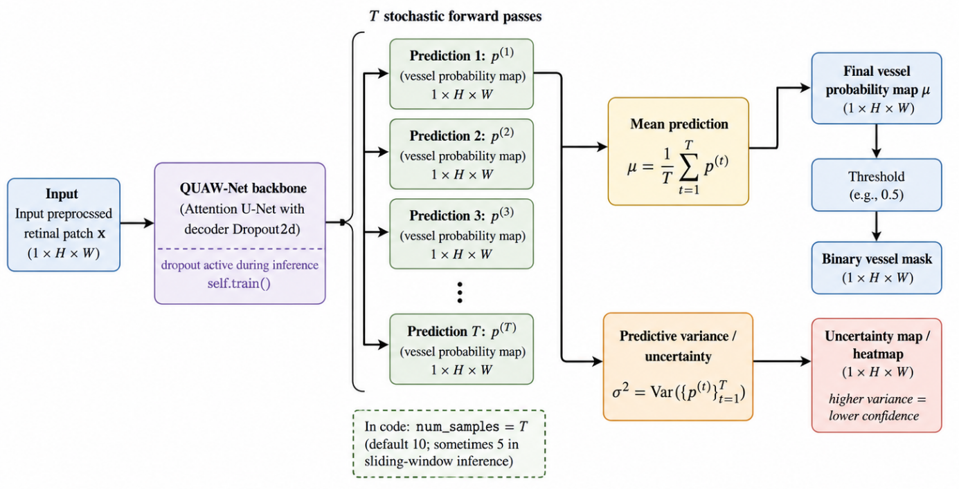
Figure 3.5 MC Dropout Uncertainty Estimation Block Diagram

Chapter 4 Detailed design and implementation of the system
This chapter describes how the retinal vessel segmentation system was designed and implemented end-to-end, from model development to application deployment. To accelerate training, the model was developed in a cloud GPU environment. After training, the best-performing model checkpoint was saved and later retrieved by the local web application. The application loads this checkpoint and generates (1) a binary vessel segmentation mask and (2) a standalone uncertainty heatmap (MC Dropout variance) for an uploaded retinal fundus image.

4.1 Implementation Details
This section introduces the implementation prerequisites, technology stack, and the overall implementation plan used to ensure the system is reproducible, stable during presentation, and consistent with the notebook training pipeline.

4.1.1 Environment Setup
The QUAW-Net system development and deployment was structured in two significant environments, the model development and the local application deployment environment. To develop a model, the training process was performed in a cloud-based GPU runtime. This was due to the fact that retinal vessel segmentation is a problem that must be trained repeatedly on image patches and the acceleration availability provided by GPUs can significantly reduce training time as compared to running the code on a CPU. It was trained with the PyTorch, which provided flexible support of the Attention U-Net backbone, AQEM module, boundary-aware loss and Monte Carlo Dropout mechanism. Once the training process was done, the best model weight values were saved and exported as a checkpoint file, which would be used later to input into the inference application.
To deploy the system, the chosen design of the system was that of a Browser/Server application. Here, the user interface with a browser-based interface is presented to the user, with the actual inference running on a Python local backend. To ensure that compatibility with scientific computing libraries is not an issue, Python 3.12 or Python 3.11 is recommended. A FastAPI and Uvicorn were used to implement a backend, with FastAPI serving as the REST API service and Uvicorn as the local web server. NumPy facilitates numerical processing, whereas PyTorch is used to load the trained checkpoint, and to execute model inference. Image reading, preprocessing, visualization and generation of an output image are performed using OpenCV and Pillow. Appropriate parameters, including the model checkpoint path, patch size, stride, segmentation threshold, number of Monte Carlo samples, and choice of devices, are loaded into a .env file.
The trained checkpoint is the linking point between local deployment stage and the notebook based development stage. The checkpoint file is then downloaded after training in the cloud environment and is stored on the local device. Upon program initiation, the server tries to find this checkpoint and ready the model to make inferences. Assuming that the checkpoint is properly configured, the uploaded retinal image can be run through the entire retinal segmentation and uncertainty estimation pipeline. But in cases where the path initially going through the checkpoint is missing or the model is not loadable, the backend itself still starts safely but blocks out the inference function and displays a clear error message of model not loaded. The design enhances reliability of the system and makes the problems to be detected before the system runs a prediction.

4.1.2 Implementation Plan
(1) Stage 1 Notebook-based model building:
The initial phase involved the design and training of the QUAW-Net model in a notebook based set-up. During this step, the retinal dataset was loaded and sorted based on the necessary training, validation and testing structure. Preparation of the fundus images to vessel segmentation was done with the same preprocessing strategy. The QUAW-Net segmentation model was subsequently trained on a cloud GPU runtime to enhance the efficiency of the computations. The model performance was validated during training, and the model weights that performed best during training were exported as a checkpoint file, which could be later used in the deployment system.

(2) Stage 2- Stage inference pipeline packaging:
The second phase involved the transformation of the trained model into an inference pipeline that could be used with minimal difficulty. To minimize the discrepancy between training and deployment, the inference application was based on a post processing rationale that was aligned with the training pipeline based on a notebook. As full-resolution fundus images could be larger than the model input size, patch-based sliding-window inference was introduced to process the image as small overlapping patches and then reassemble the final output. Moreover, Monte Carlo Dropout-based uncertainty measures were introduced by maintaining a dropout at inference and by calculating (or estimating) the pixel-wise variance of various stochastic predictions.

(3) Stage 3 - Lightweight web application:
The third phase involved development of light-weight web-based demonstration system. A one page frontend was created to enable users to upload a retinal picture and choose one of the inference modes, like Fast or Accurate. This was implemented using a FastAPI backend to load the trained checkpoint, run the inference pipeline, produce output artifacts, and provide result URLs along with quantitative statistics. To create a clear output to be presented and to demonstrate the segmentation mask of the binary vessel model and showcase a purely high-contrast uncertainty heatmap, the output design has been intentionally kept simple.

4.2 Implementation Process
Table 4.1 Core Components of the QUAW-Net Implementation
Component | Description | Contribution
Loss Function | Boundary-aware loss function | Enhances the quality of the segmentation by focusing on the regions of the boundaries, which ensures a better edge detection.
Backbone | Attention U-Net | Enhances feature extraction by concentrating on the relevant areas, which enhances the performance of the segmentation.
AQEM (Annotation Quality Estimation Module) | Dynamically modulates the weights according to the quality of annotations. | Improves learning from multi-annotator datasets by emphasizing high-quality annotations.
Monte Carlo Dropout | Introduced in inference so that it can quantify uncertainty and thus make the model more robust and understandable. | Provides uncertainty quantification, making the model more robust and interpretable.
Temperature Annealing | Gradually decreases temperature during Phase 3 | Refines predictions by concentrating on confident predictions, resulting in improved segmentation results.
Progressive Training Strategy | Three-phase Training: Uniform, AQEM, and Annealing phases | Ensures gradual improvement in model performance by focusing on different aspects in each phase.
Dataset | CHASE_DB1 (28 retinal images with 2 expert annotations per image) | Provides a high-quality dataset used to train and evaluate, making it possible to have multi-annotator learning.
Validation Metrics | Dice coefficient, IoU, and uncertainty | These are used to measure the model performance and to ensure that the model generalizes to unseen data.

4.2.1 Data Preparation
(1) loading and organization of datasets:
The notebook will store the retinal fundus images and their matching vessel annotation mask into a standard format to train, validate and test. The annotation files are loaded as individual label sources instead of being combined into a single ground truth mask since the selected dataset has a number of manual annotations per retinal image. The training pipeline leveraged by this organization can learn various expert segmentations, and the quality-conscious annotation weighting mechanism employed in QUAW-Net can be trained by this organization.

(2) Standardization and preprocessing of input:
To minimize the change in illumination and enhance the visibility of the vessel, the system uses a uniform preprocessing pipeline prior to model inference. The green channel (extracted) of the retinal image is because retinal blood vessels tend to exhibit greater contrast in this channel. Then, light correction is used to minimize variations in brightness, vignetting, and variations in the global brightness. Then, CLAHE is applied to increase the local contrast and help to make thin vessel structures more noticeable. Lastly, a strong percentile normalization is done so as to stabilize the image intensity range across the various samples allowing the model to receive more consistent input data.

(3) Patch-based processing requirement:
The fixed input patch size by which the model is built is often smaller than the retinal fundus images. The simple resizing of the entire image to a very small resolution can lead to the loss of thin vessels and boundary details. Thus, a patch-based sliding-window approach with overlap is used in the system. In this method, the entire image is broken down into smaller patches based on the specified patch size and stride and each patch is processed by the model and the overlapping predictions are averaged to reconstruct the final full-image vessel probability map. This renders the system computationally viable and yet retains valuable vessel information.
(4) Dataset selection rationale and experimental boundary:
Since QUAW-Net adopts annotation quality-weighted supervision, the selected dataset must contain at least two independent expert annotations for each image. CHASE_DB1 was selected because it provides 28 retinal fundus images and two ground-truth vessel annotations for each image, forming 56 expert annotation masks for multi-annotator supervision.^{[18]} The number “56” therefore refers to annotation masks, not to 56 independent fundus images. Within the time and resource scope of this thesis, CHASE_DB1 was the dataset that could be most directly obtained, verified, and organized into the required dual-expert training format. Other widely used retinal vessel datasets and protocols, such as DRIVE and STARE, remain valuable for ordinary segmentation benchmarking, but their annotation organization and evaluation protocols are not directly identical to the sample-level dual-annotation learning setting used in this thesis.^{[15][16]} For this reason, the present experiment focuses on CHASE_DB1 as the qualified dataset for validating the proposed AQEM-based supervision mechanism.

4.2.2 Model Development (QUAW-Net + AQEM + MC Dropout)
The model is trained using the CHASE_DB1 fundus image dataset, which provides two manual vessel annotations and a field-of-view (FOV) mask for each retinal image.^{[18]} As retinal blood vessels tend to exhibit higher contrast in the green channel, each RGB fundus image is converted into a one-channel grayscale representation, which is then used as model input data. Therefore, the input and output channel structure of the model is determined as:

$\begin{aligned}C_{in}=1,C_{out}=1\#\left(4.1\right)\end{aligned}$

A preprocessing pipeline is fixed and used uniformly in training, validation and testing stages to minimise variation of images so that more vessels can be identified during training, validation and testing stages. First the green channel (I g ) is picked out of the RGB picture. Then, the light correction is done by approximating the background heavily blurred using Gaussian blur (sigma=25.0), and then division-based normalization is done to eliminate the uneven lighting and vignetting effect. Then, CLAHE is used with the following settings: clipLimit = 2.0 and tileGridSize = (8,8) to increase the contrast of the locality, in particular, thin vessels and the boundaries of the vessels with low contrast. Lastly, it has a strong percentile normalization which is done using:

$\begin{aligned}p_{low}=1.0,p_{high}=99.0\#\left(4.2\right)\end{aligned}$

The preprocessing function has two outputs, the processed image, represented as a array of float32 in the range ([0,1]) which is used as the input to the model and the raw green-channel image which is also normalized in the range ([0,1]) and is retained to visualize and refer to.

To enable the model to be trained on image patches rather than on entire-resolution retinal images to increase the size of the effective training sample and make training more stable on the limited CHASE_DB1 training data. The size of each training patch is (128 x 128) with 20 training patches being sampled on each image at each epoch and a batch size of 4. This patch based approach enables the model to learn local vessel patterns in a more effective manner as well as consumes a lesser memory load when undergoing training.

The patch sampling procedure is FOV-conscious as well as vessel-conscious to prevent the usage of the patch samples that are either the patches that contain predominantly black background or the patches that have a very small number of pixels representing the vessels. The minimum requirement of the patches is that they have to cover at least half the FOV, expressed in terms of the ratio of minimum fov to the minimum vessel coverage ratio: min_fov_ratio = 0.50. When the patch of the sample selected fails to meet the sampling specifications, the notebook tries to resample up to 10 times with the following command: resample_tries = 10. This is done by calculating the vessel ratio as the combination of the two manual annotations within the FOV region so that the patch has valuable information about the vessels.

Simple geometric data augmentations are used during training to enhance generalization without affecting the retinal vessels anatomy. These augmentations consist of random left-right flipping with probability: 0.5, random up-down flipping with probability: 0.5 and random rotation by:

$\begin{aligned}k×{90}^{∘},k∈0,1,2,3\#\left(4.3\right)\end{aligned}$

To be validated, deterministic patches are employed in a way that the performance can be compared equally across epochs. Thus the training dataset is where the augment=True and deterministic_patches=False and the validation dataset is where the augment=False and deterministic_patches=True and the random generator seeded as seed +idx. The training split of the CHASE_DB1 that has 20 images is split by image using train test split (test size=0.2, random state=42). In post-split analysis patch indices are augmented in such a way that validation can be measured at a predetermined set of patch locations.

An encoder-decoder U-Net variant with attention gates on the skip connections is the backbone of the segmentation backbone of QUAW-Net. The encoder then uses hierarchical vessel-related features out of the preprocessed retinal image patch and the decoder then slowly restores spatial resolution to generate a pixel-wise vessel probability map. The feature channels used to the encoder stages is ([64,128,256,512]). A convolutional block is composed of two (3 x 3) convolutional operations then Batch Normalization and ReLU are carried out. The upsampling blocks are upsampled using bilinear upsampling and then convoluted, Batch Normalization and ReLU activation.

The skip features are filtered with attention blocks and finally concatenated with the encoder features (Unlike a standard U-Net). This attention process assists in the repression of the irrelevant background information, and enhances the representation of vessel-related territories. To help estimate uncertainties and minimize overconfident predictions, we insert the Dropout2d between the decoder pathway with a dropout rate of 0.35. To avoid uncertainty collapse, and to make Monte Carlo Dropout more informative when making inferences, this dropout setting was also increased.

The last convolution of the model is (1 x 1) convolution after which there is a sigmoid activation function. So, the result is a vessel probability map:

$\begin{aligned}\hat{y}∈{\left[0,1\right]}^{H×W}\#\left(4.4\right)\end{aligned}$

The convolution layers have their weights initialized using Kaiming normal initialization and the weights of the BatchNorm are initialized to 1 and the weights of the bias are initialized to 0. The strategy of this initialisation aids in stabilizing initial training, and facilitates more smooth convergence.

One of the main contributions of this thesis is the Annotation Quality Estimation Module (AQEM) which learns per-sample quality weights between different annotators. In multi-annotator retinal vessel segmentation, there can be disagreement between different expert masks particularly in the areas of thin vessels, low contrast areas and the boundary of the vessels. AQEM only lets go of the entirety of annotations, instead estimating the level of reliability of any given annotation on the current training sample.

Each training sample and each annotator (k) is input to AQEM by concatenating of input image patch (x), annotator mask (y_k) and the prediction of the model (hat y). The prediction is not connected to the gradient and then fed into AQEM to prevent the occurrence of unstable feedback loops when training. The AQEM architecture constitutes of a pair of convolutional layers with input of 32 channels, Batch normalization and Relu activation, followed by the Global average pool and the fully connected layer architecture of (32 16 1). The outcome of this is one quality logit (s k ) per annotator.

The logits are then concatenated together, so that the concatenated logits are:

$\begin{aligned}s=\left[s_{1},…,s_{K}\right]\#\left(4.5\right)\end{aligned}$

The logits are then transformed into normalized weights of the annotators using a temperature-scaled softmax function:

$\begin{aligned}w_{k}=\frac{exp\left(s_{k}\text{/}T\right)}{\sum_{j=1}^{K}{exp\left(s_{j}\text{/}T\right)}}\#\left(4.6\right)\end{aligned}$

In Phase 1, AQEM is turned off and an equal weight is given to all annotators:

$\begin{aligned}w_{k}=\frac{1}{K}\#\left(4.7\right)\end{aligned}$

Phase 2 and later AQEM is turned on and the weights of the annotator layers are created using the softmax function above. This enables the model to progressively transition between equal annotation supervision, to quality-sensitive annotation supervision.

This training goal is a combination of quality-weighted Dice loss and a boundary-aware BCE loss. The Dice term is a term that promotes an overlap between the predicted vessel mask and the manual one regionally, whereas the boundary-aware BCE term is a term that promotes a regionally-based overlap between the predicted vessel mask and the manually made one. The loss weights should be defined as follows ( lambda 1 = 1 ) where the boxes are the Dice term, the boundary term and the entropy regularization.

To compute Dice loss, the loss of both annotators first are computed separately on each individual annotator, and then these loss amounts are added up using AQEM-generated weights. The quality weighted Dice loss can be expressed in the following manner:

$\begin{aligned}L_{\text{dice}}=E_{i}\left[\sum_{k=1}^{K}{w_{i,k}}l_{\text{dice}}\left(\hat{y_{i}},y_{i,k}\right)\right]\#\left(4.8\right)\end{aligned}$
where:

$\begin{aligned}l_{\text{dice}}=1-\text{Dice}\left(\hat{y}*i,y*i,k\right)\#\left(4.9\right)\end{aligned}$

A morphological-gradient-like operation with an (3 times 3) averaging kernel and thresholding operations which mimic dilation and erosion are used to compute a boundary-conscious BCE loss. A spatially weighted map is constructed in the form of:

$\begin{aligned}alpha\left(p\right)≔1+alpha-boundary\left(y\right)\left(p\right),wherealpha=2.0\#\left(4.10\right)\end{aligned}$

This weight map makes the contribution of the loss of the boundary pixel to be more significant. Like the Dice term, the loss at the boundary is calculated per sample, as well as per annotator and then summed using AQEM weights:
$$\begin{aligned}L_{\text{boundary}}=\frac{1}{N}\sum_{i=1}^{N}{\sum_{k=1}^{K}{w_{i,k}}} l_{\text{bnd}}\left(\hat{y_{i}},y_{i,k}\right) \#\left(4.11\right)\end{aligned}$$
This design does not bias the model to a high-quality annotator and it permits the region-level and the boundary-level supervision to adapt itself to the quality of annotators.

The regularization of entropy is also stipulated in the code; it, however, has been switched off in the present experiment. An entropy of the weights of the annotations is calculated as:

$\begin{aligned}H\left(w\right)=-\sum_{k}{w_{k}log\left(w_{k}\right)}\#\left(4.12\right)\end{aligned}$

The loss of entropy regularization can be defined as:

$\begin{aligned}L_{\text{entropy}}=-H\left(w\right)\#\left(4.13\right)\end{aligned}$

When this is turned off, minimizing this term will increase the entropy (and hence the uniformity of annotator weights). But in this notebook the entropy regularization is switched off by the following setting:

$\begin{aligned}λ_{3}=0.0\#\left(4.14\right)\end{aligned}$

The overall loss will be:

$\begin{aligned}L=λ_{1}L_{\text{dice}}+λ_{2}L_{\text{boundary}}+λ_{3}L_{\text{entropy}}\#\left(4.15\right)\end{aligned}$

The model is optimized with AdamW with different blocks of parameters of the segmentation backbone and AQEM. The parameters of the backbone are a learning rate of (1 x 10 -4) and weight decay (1 x 10 -4). The parameters of the AQEM make use of a learning rate which is multiplied by the value AQEM LR MULT = 5.0, producing the learning rate (5 multiplied with 10 -4), and the same weight decay. The design enables AQEM to more quickly adjust to variations in the quality of annotations without pushing the backbone parameters too aggressively.

A ratio-preserving cosine schedule of learning-rates is used, with the help of LambdaLR. This scheduler scales all the parameter groups by the same factor in such a way that the ratio between the learning-rate of the backbone and that of AQEM does not change during training. The minimum learning-rate factor will be fixed at; min learning rate factor = 0.01.

To choose the model, the best model is stored each time there is an improvement in the validation Dice score. The optimal checkpoint is saved as the best model.pth which contains the state of the model, state of the optimizer, best Dice score, and configuration information. Moreover, the periodic checkpoints are saved at the end of the epoch, in epoch metrics, such as AQEM weight statistics. The checkpointing approach will guarantee that the model that has demonstrated the best performance can be reused to perform tests and rollout.

The training process lasted for 100 epochs and followed a three-phase progressive strategy. During Phase 1 (epochs 1–30), AQEM was deactivated and all annotations were assigned equal weights (0.5 each), allowing the backbone network to learn an initial vessel representation. During Phase 2 (epochs 31–60), AQEM was activated with a high temperature value of 2.0, allowing the model to learn soft annotation-quality weights without making overly sharp decisions. During Phase 3 (epochs 61–100), temperature annealing was applied by gradually reducing the temperature from 2.0 to 0.2. This made the AQEM softmax distribution sharper and encouraged the model to assign stronger weights to the annotations estimated to be more reliable.
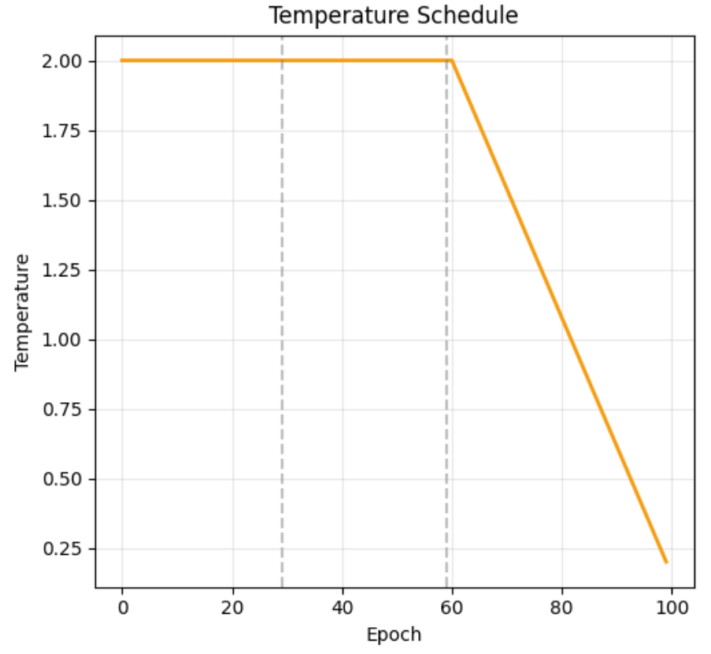
Figure 4.1 Temperature Schedule for Progressive Training
Monte Carlo Dropout is used to estimate the uncertainty. In inference or a validation, dropout is maintained and the model is inferred on the same input image or patch several times. During MC Dropout inference, the model is kept in evaluation mode while only the dropout layers are activated to generate stochastic predictions.

$\begin{aligned}\text{Uncertainty}\left(p\right)=\text{Var}\left(\hat{y^{\left(1\right)}}\left(p\right),…,\hat{y^{\left(T\right)}}\left(p\right)\right)\#\left(4.16\right)\end{aligned}$

To compute Dice and IoU, both training and validation are calculated on a per annotator basis and the average among annotators is the score most often reported. The FOV mask hides predictions and labels prior to metric calculation such that an evaluation is made on the valid retinal region.

4.2.3 App Deployment

Application deployment phase transforms trained QUAW-Net model into a lightweight local inference system. The backend is realized based on FastAPI and offers two major API endpoints. Status of model loading, device data, and critical runtime configuration options are provided by the model loading status, device information, and important runtime configuration parameters, located in the endpoint: GET /api/info. The API endpoint is the POST /api/predict?mode=fast|accurate which accepts a retinal image uploaded to the endpoint, runs the inference pipeline, and provides result URLs along with quantitative statistics. To achieve result persistence, every prediction generates its own directory under the output/results directory and the backend mounts the path /results to be a fixed path such that generated PNG artifacts can be directly served to the browser.

The inference pipeline preprocesses the retinal image that was uploaded using the same general reasoning as the notebook pipeline. It then approximates the field-of-view mask in such a way that it can report statistics in a more meaningful manner within the valid retinal region. Since full-resolution fundus images can be a lot larger than the size of the input patch to the model, sliding-window inference is employed to reconstruct the full-image vessel probability map using overlapping patches. Monte Carlo Dropout is used when making inferences with a number of stochastic samples and the Fast and Accurate modes differ primarily by the number of MC samples. The system produces three major visual artifacts to be presented namely the original image, the binary vessel mask as well as a standalone high-contrast continuous uncertainty heatmap without superimposing it on the original image.

The frontend is supported by the backend as a single page interface (HTML/CSS/JavaScript), which is a static page. The interface is deliberately simple so as to allow a seamless thesis demonstration. The user loads an image, clicks on the mode of inference, runs the prediction and then views the three generated outputs sequentially in addition to a small table of meaningful numerical indicators.
Figure 4.2 shows the running interface of the deployed QUAW-Net application. Through this interface, the user can upload a retinal fundus image, run the trained segmentation model, and view the generated outputs, including the original image, predicted vessel mask, uncertainty heatmap, and quantitative inference statistics. This screenshot demonstrates that the trained model was successfully integrated into a practical web-based inference system.

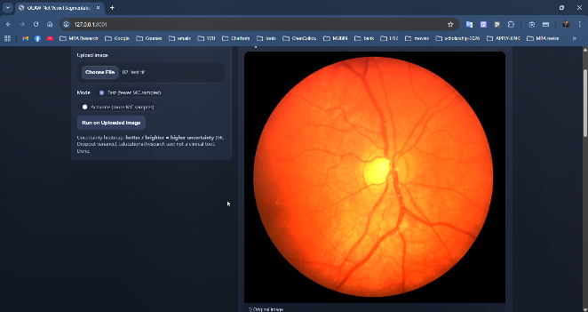
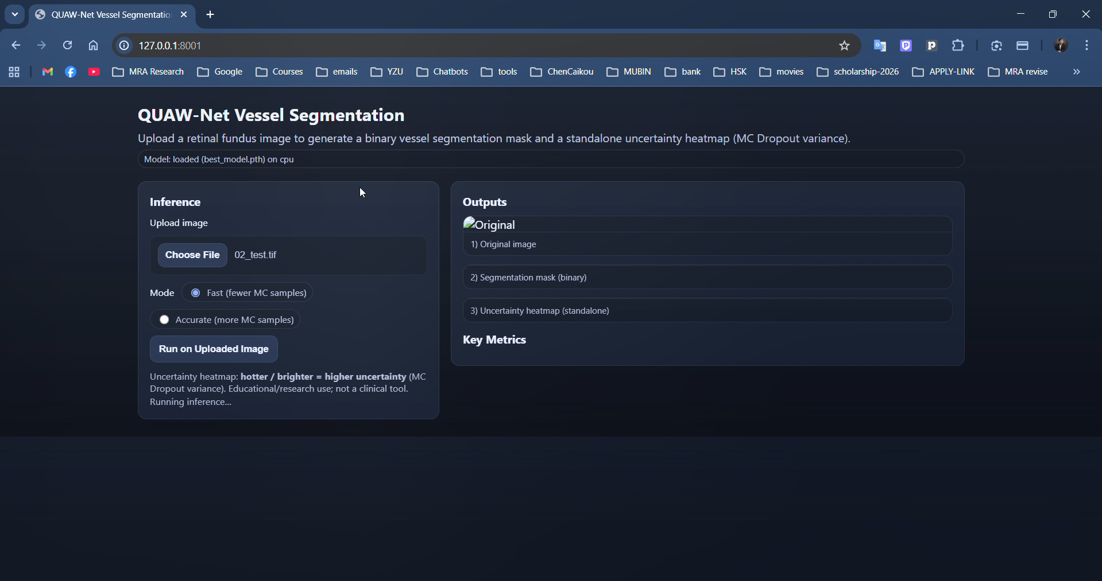
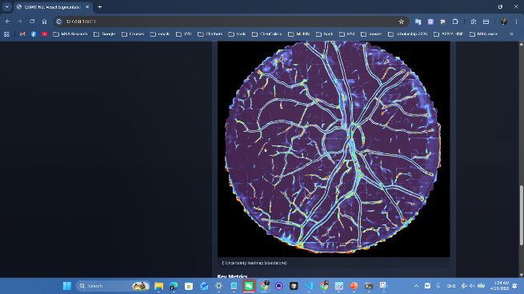
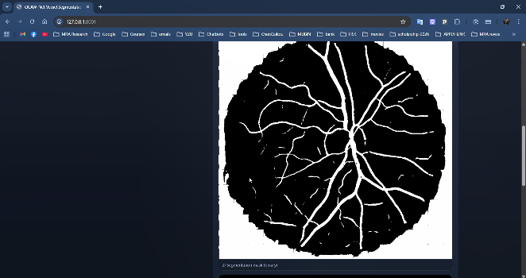

Figure 4.2 Running Interface of the QUAW-Net Retinal Vessel Segmentation Application

The source of the truth on how the model was trained and validated is the notebook. The deployed application has a similar model family and a consistent preprocessing and inference strategy to minimise the mismatch between training assumptions and deployment behaviour. The checkpoint modeled in the notebook is the very file loaded by the backend and this provides accountability on how the model was developed through to the final deployment of its application.

Chapter 5 System Test and Result
The training process was separated into three different phases: Uniform Weighting, AQEM (Annotation Quality Estimation Module) using high temperature and Temperature Annealing. Dice coefficient, Intersection over Union (IoU) and uncertainty were some of the measures used to evaluate the performance of the model. The model with best performance was not only saved, but also tested using a different test dataset.

5.1 Training Progress and Results

5.1.1 Training Phases
The training process was implemented in the number of epochs (100) and it was divided into three phases:
Phase 1 (Epoch 1-30): Uniform weighting of annotations was done.
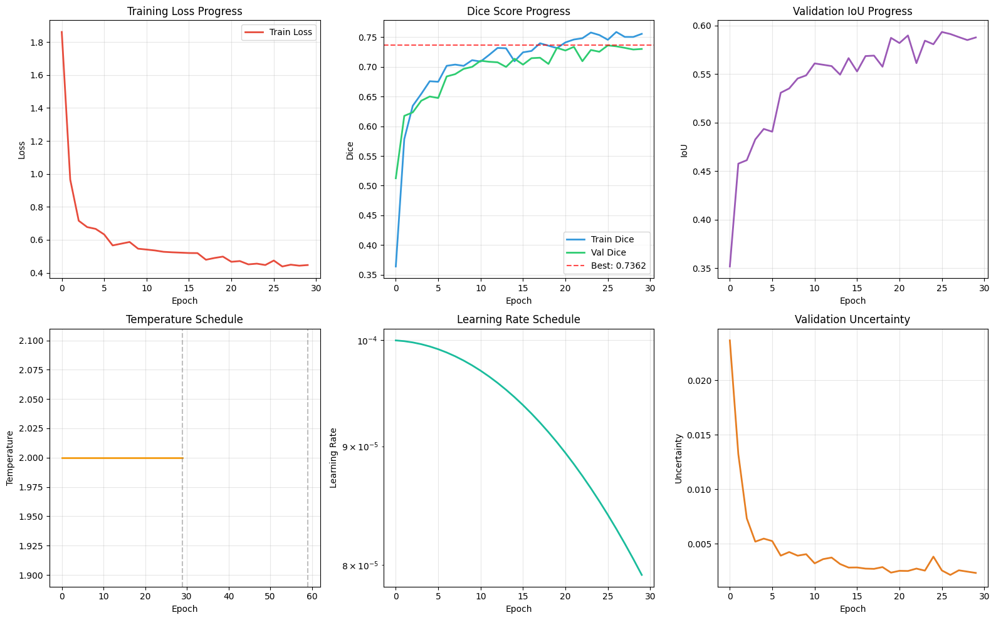
Figure 5.1 Training Loss, Dice, IoU, Temperature, Learning Rate, and Uncertainty Curves

Phase 2 (Epoch 31-60): to promote annotation quality, Phase 2 was set up with high temperature.
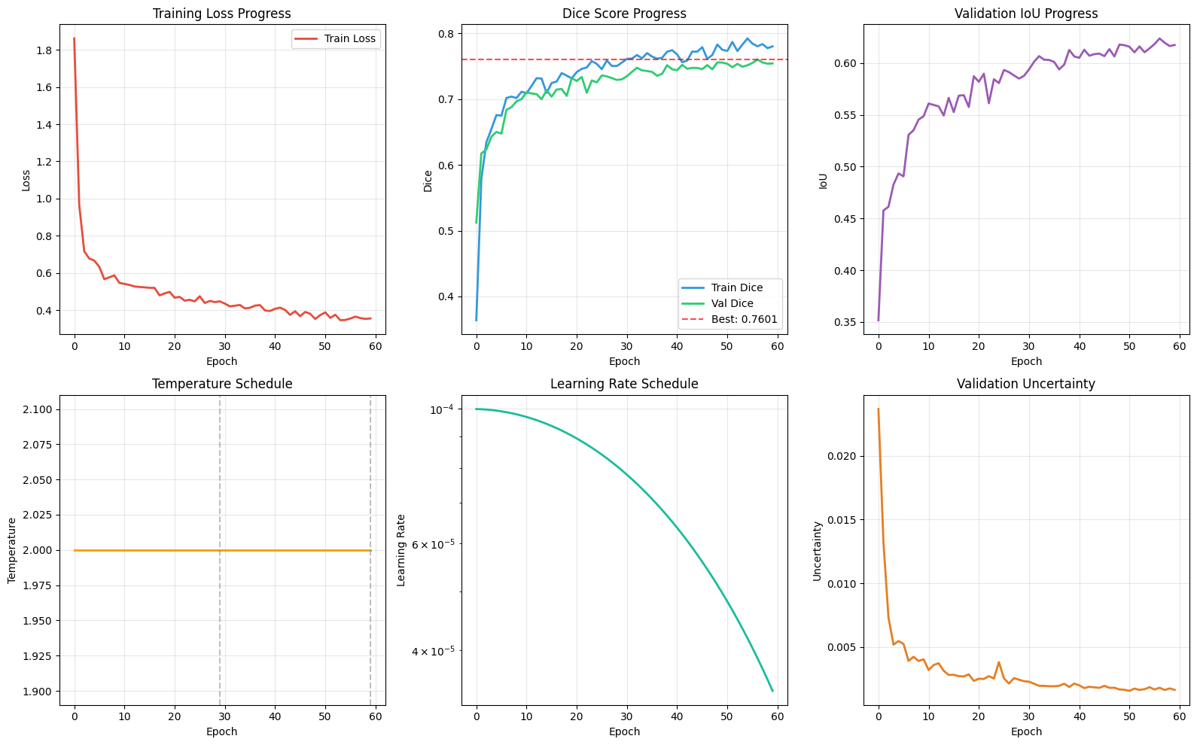
Figure 5.2 Validation Performance Curves During Progressive Training
Phase 3 (Epoch 61-100): Temperature annealing was used to make fine-tuning of the predictions of the model.
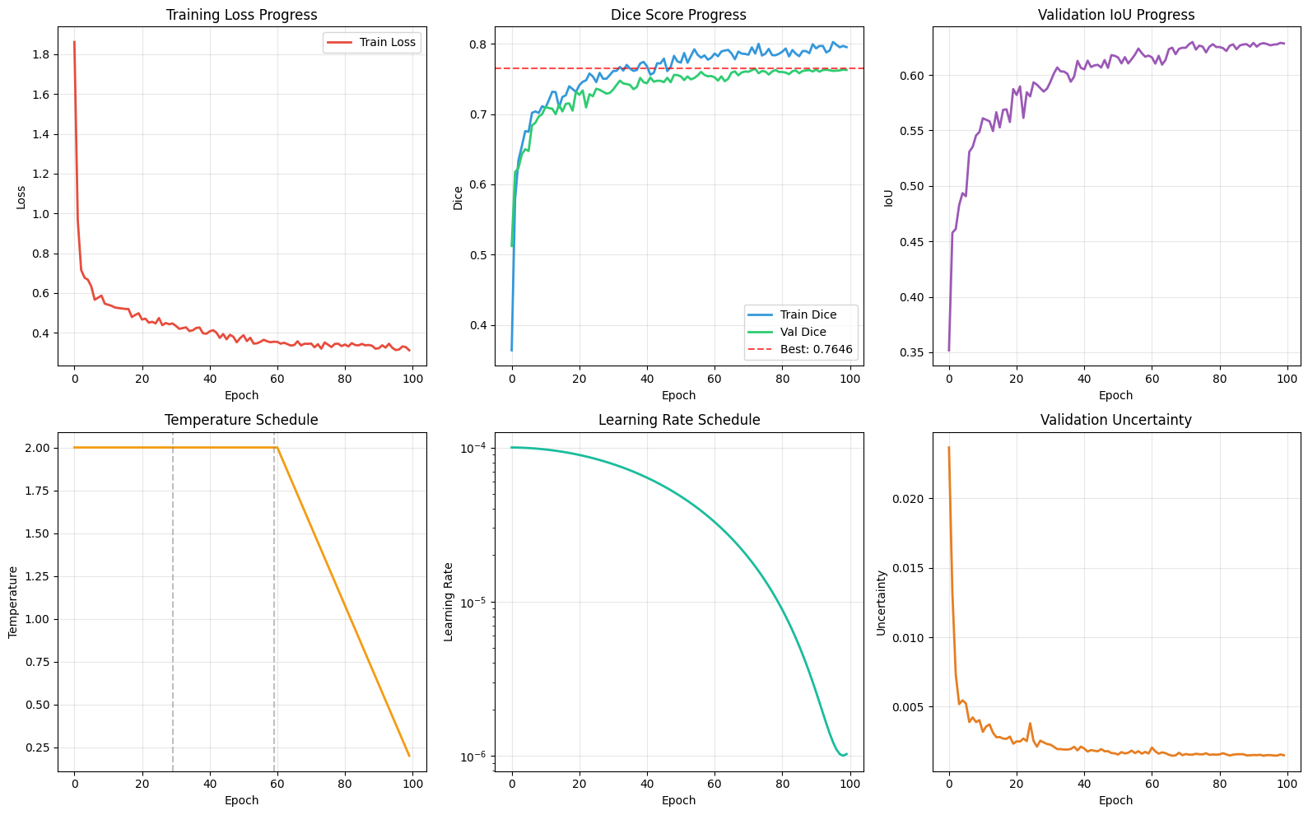
Figure 5.3 Overall Training Progress Dashboard

5.1.2 Training Metrics
Each epoch recording of the training metrics, such as Dice coefficient, IoU, and uncertainty was kept. Epoch 73 in Phase 3 had the best Dice score of 0.7646. The time that was spent on the training process was 1 hour, 9 minutes and 22 seconds.

Table 5.1 Training Metrics Summary
Metric | Value
Best Dice Score | 0.7646
Epoch of Best Dice | 73
Total Training Time | 1h 9m 22s

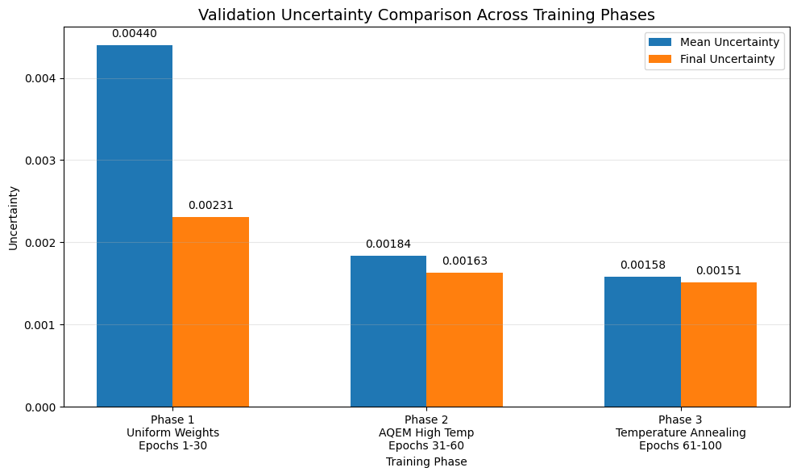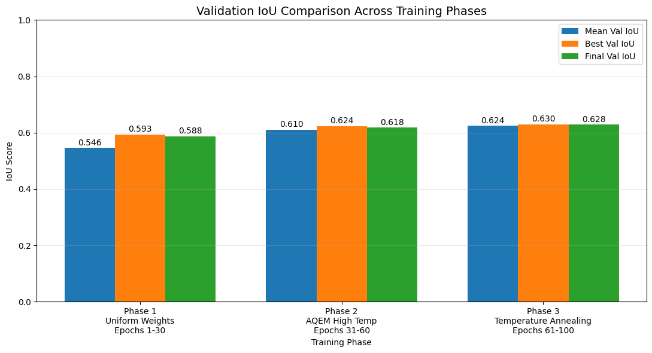

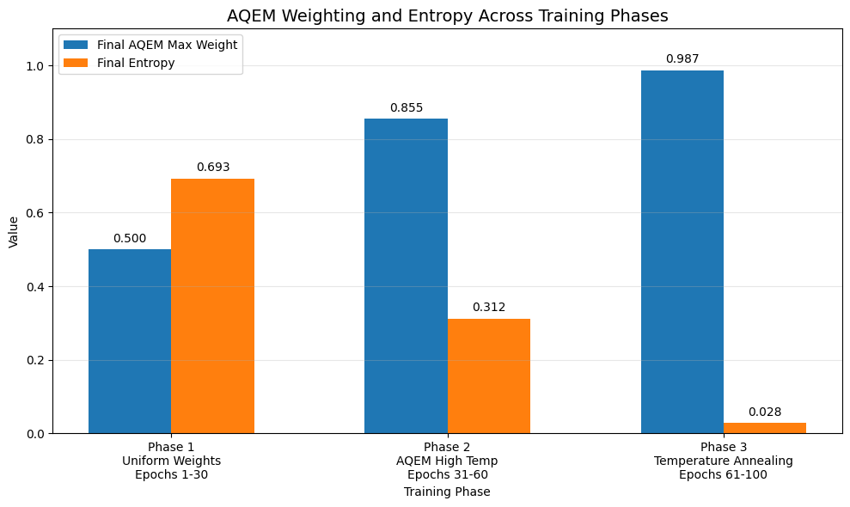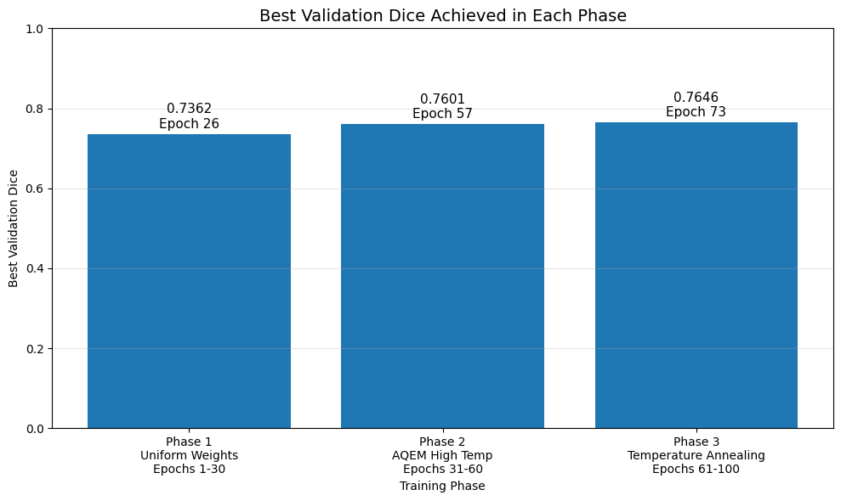
Figure 5.4 Performance Comparison Across QUAW-Net Training Phases

5.2 Module Analysis and Effects

5.2.1 AQEM Module
The inclusion of the AQEM module in the model greatly enhanced the performance of the model in the Phase 2. The model was able to output a higher Dice score, as well as less uncertainty, due to dynamic weight adjustments through the quality of annotations. The upper weight that was put forth by AQEM had a maximum of 0.987 in the final epoch thereby showing its effectiveness in highlighting annotation quality

5.2.2 Temperature Annealing
In Phase 3, the model predictions were further refined through temperature annealing. The gradual decrease in temperature encouraged AQEM to assign stronger weights to more reliable annotations, which contributed to the highest validation Dice score of 0.7646.

5.3 Test Set Evaluation
The optimal model was tested on held-out CHASE_DB1 samples, including 40 patches from 8 test images. The experiment uses CHASE_DB1 because its two independent expert annotations per image match the AQEM multi-annotator supervision requirement.^{[18]} Therefore, the evaluation emphasizes internal validation under a qualified dual-annotation setting rather than broad cross-dataset benchmarking. This design is suitable for demonstrating the mechanism of QUAW-Net, but the result should be interpreted as an initial validation rather than a complete state-of-the-art comparative evaluation.

Table 5.2 Test Set Metrics
Metric | Value
Test Dice (Mean) | 0.7248
Test IoU (Mean) | 0.6131
Test Uncertainty (Mean) | 0.00125

5.4 Model prediction and uncertainty heatmap
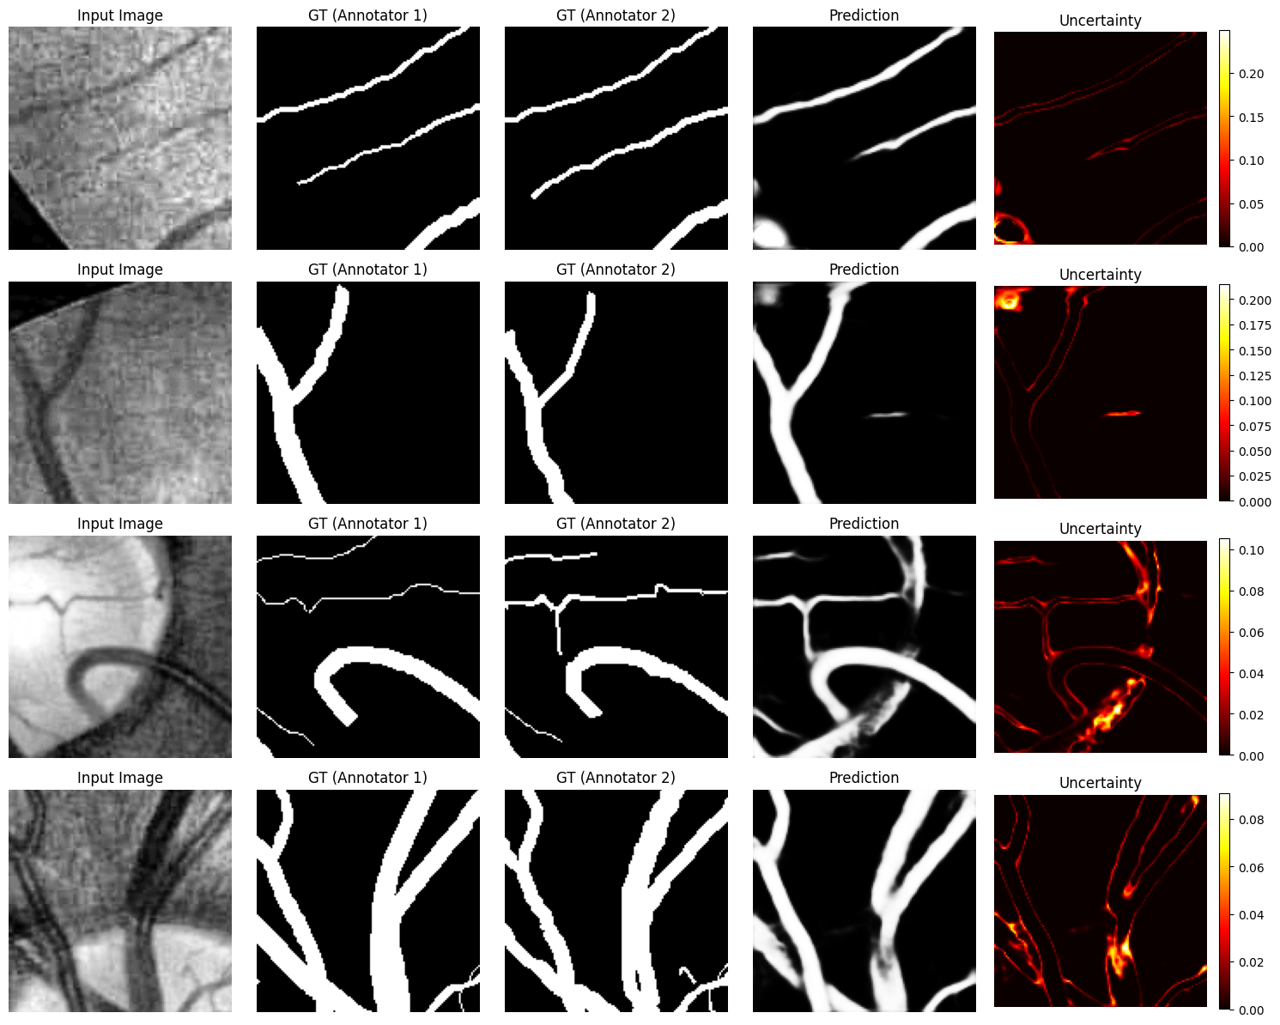
Figure 5.5 Model Prediction and Uncertainty Heatmap

Figure 5.5 provides qualitative examples of the results of the model prediction and uncertainty estimation of retinal image patches. There is one test sample per row and the columns represent the input image, ground truth mask of Annotator 1 and 2, predicted vessel probability map and the uncertainty heatmap. Such visualization will aid in both assessing whether the model is capable of segmenting vessel structures, as well as whether the model is able to identify uncertain or ambiguous areas in the prediction.

Based on the prediction column, it is evident that the model has been able to reproduce most of the major vessel structures in most cases. Thick and clearly visible vessels, including major branches, are segmented with relatively smooth and continuous responses. In (1) and (2), the projection of the vessel map used in the prediction takes the direction of the main vessel and gives a good agreement with the two additional vessel maps. Even in the third and fourth rows where the vessel constructions are more complicated, and where there is a larger intensity variation in the background, the model still manages to distinguish the main vessel areas, albeit with some thin branches and boundary details less well represented.

The comparison between Annotator 1 and Annotator 2 also reveals that manual annotations of vessels are not necessarily similar. It is possible to observe some of the differences around thin vessels, edges of vessels and small areas of branches. This establishes that there is multi-annotator disagreement in the data. As a consequence, when all annotations are treated as being equally reliable, this could create noise in the training process. The proposed AQEM module applies to this case since it is able to assign adaptive weights to the various annotations according to the estimated quality so that the model can learn using more reliable instances of supervision.

The uncertainty heatmap will give more details concerning the confidence of the model forecast. The brighter the region in the heatmap, the greater the predictive uncertainty and the darker the region, the less the uncertainty. It is found that uncertainty tends to be more prevalent near the vessel boundaries, near the thin vessel ends, near the branching and near the locations close to strong background artifact. This is a sensible pattern as such regions are aesthetically more challenging to differentiate, as well as more likely to experience disagreement among human annotators. As an example, where high uncertainty is observed in the 3 rd and 4 th rows is where intersections of complex vessels and curved vessel structures are observed, with the predicted boundaries of vessels having less certainty.

5.5 Discussion
The experimental results indicate that the proposed framework can address key challenges of multi-annotator retinal vessel segmentation within the CHASE_DB1 setting. First, AQEM reduces the influence of label noise and annotator disagreement by estimating quality weights for each annotation. Instead of simply averaging inconsistent labels, the supervision signal can give greater influence to annotations judged to be more consistent with the image content and the current prediction. This is particularly important for thin vessels and blurred boundaries, where expert disagreement is more likely to occur.
Temperature annealing also contributed to stable model training. In the early training stage, high-temperature soft weighting allowed the model to learn the general vessel topology from both annotations without making overly sharp weighting decisions. In Phase 3, gradually reducing the temperature produced a sharper weight distribution, which encouraged the model to focus more strongly on the annotations estimated to be more reliable. This progressive strategy helped the model move from general vessel-structure learning to more quality-sensitive supervision.
Although the validation Dice score of the model was 0.7646 and the test Dice score was 0.7248, the experimental design has an important limitation. CHASE_DB1 contains 28 fundus images and two expert annotation masks per image; therefore, the available multi-expert supervision consists of 56 annotation masks rather than 56 independent retinal images.^{[18]} Only 20 images were used for training/validation splitting and 8 images were used for testing, so the model may still be sensitive to anatomical and imaging differences between the splits. Since only one verified and directly usable dual-annotation dataset was used in this thesis, the current experiment cannot fully demonstrate cross-dataset generalization. In addition, this thesis did not implement a full quantitative comparison with representative baselines and state-of-the-art methods such as U-Net, Attention U-Net, and IterNet under the same preprocessing, split, and evaluation protocol.^{[7][11][14]} Therefore, the results should be understood as evidence that the proposed AQEM strategy is feasible and useful under a multi-expert annotation setting, rather than as conclusive proof that QUAW-Net is superior to all existing retinal vessel segmentation methods.
To address this limitation in future work, the experiment should be expanded in two directions. First, more datasets with multiple expert annotations should be collected, constructed, or re-annotated by qualified experts; if only single-reference datasets are available, an additional expert annotation should be produced before applying AQEM. Second, QUAW-Net should be compared with representative baselines and SOTA methods, including U-Net, Attention U-Net, IterNet, and recent retinal vessel segmentation networks, using identical preprocessing, the same train/validation/test split, and consistent metrics such as Dice, IoU, sensitivity, specificity, and AUC.^{[7][11][14]} Such comparative verification would allow a fairer assessment of both generalization and methodological superiority.
Another way the MC Dropout uncertainty maps enhanced the interpretability of the system was through the use of uncertainty maps. There was a higher uncertainty rating on hard-to-separate areas such as ends of tiny vessels and near the edges of the optic disc where the disagreement by annotators will naturally tend. This demonstrates that the model is not only able to produce a vessel segmentation mask but it can also be useful in the sense that it can offer information on the confidence of the prediction. This visualization of uncertainty may enhance clinical transparency since users will be more aware of which of these regions of the prediction is more probable and which areas will have to be carefully observed by users.
In summary, the combination of quality-aware annotation weighting and stochastic uncertainty estimation makes QUAW-Net a promising and interpretable framework for retinal vessel segmentation when the available ground truth is subjective or inconsistent across annotators. The current findings support the rationality of the proposed structure on the qualified CHASE_DB1 setting, but broader validation with additional multi-expert datasets and direct SOTA comparisons is still required before claiming general superiority.^{[18]}

Chapter 6 Conclusion
This thesis, based on its robust, quality-conscious and uncertainty-conscious deep learning structure, QUAW-Net, has succeeded in developing and deploying a structure of high quality in vessel detection and segmentation in the human retinal veins. The recommended approach tackles two critical issues of the medical image segmentation multi-annotator disagreement and the inability to estimate the confidence of the model predictions. Made of an Attention U-Net-based backbone of segmentation, an Annotation Quality Estimation Module (AQEM) and Monte Carlo Dropout-based uncertainty estimation, the study is a practical framework that increases the strength and interpretability of segmentation.
Results demonstrate that quality conscious learning can be effectively used to deal with inconsistent supervision. The AQEM module uses dynamically the various weights to the expert annotations depending on the estimated reliability of the expert annotation. The model in this study reached a maximum annotation weight of 0.987 hence revealing that when there was a disagreement, the model was able to identify and rank the most reliable annotation weight. This assisted the model in learning based on stronger supervision senses rather than taking into account all of the manual annotations alike.
It was also through progressive training strategy that has helped to develop stable models. The training was split into three stages such as uniform annotation weighting, weighting based on AQEM, and quality estimation based on temperature. This progression enabled the segmentation backbone, to initially learn the general vessel structure, and then narrows down its learning with quality conscious annotation weights. Consequently, the proposed training strategy enabled the model to effectively reach its best validation Dice score of 0.7646 at epoch 73, illustrating that the proposed training strategy was effective in supporting effective convergence.
Another key finding is that Monte Carlo Dropout has led to a greater amount of interpretability in regard to the system. The model produced uncertainty maps and vessel segmentation masks by keeping dropout active during inference, and performing many stochastic forward passes with dropout. Such uncertainty maps were able to give focus on the doubtful areas like low contrast boundaries and regions where there was a higher probability that there was disagreement in the annotation. Thus, the system does not solely produce a segmentation outcome but rather provides informative data concerning prediction-confidence which can be vital not only to clinical transparency and decision support but also potentially to provide a segmentation result.
The held-out test result also provides a preliminary indication of generalization. The model achieved a mean Dice score of 0.7248 and a mean IoU of 0.6131 on the test set, suggesting that the learned vessel representation can transfer to unseen retinal image patches within CHASE_DB1. However, the validation-test performance gap also reflects the difficulty of retinal vessel segmentation under a small-data setting. Differences in vessel thickness, local contrast, and annotation style can influence the result, especially when only a limited number of images are available. The trained checkpoint was successfully deployed as a lightweight FastAPI-based web application, confirming that the model can be demonstrated through a reproducible local inference system.
Overall, QUAW-Net provides a useful framework for retinal vessel segmentation when the available ground truth is subjective or variable across annotators. The combination of quality-aware annotation weighting and stochastic uncertainty estimation makes the framework more robust and interpretable for preliminary multi-expert medical image analysis. However, the present experiment is limited by the small scale of CHASE_DB1 and by the use of only one verified and directly usable multi-expert dataset.^{[18]} Therefore, the contribution of this thesis should be understood as method design and preliminary validation of annotation quality-weighted supervision, not as a final SOTA benchmark. Future research should collect or construct additional multi-expert annotation datasets, extend the evaluation to more retinal image sources, and conduct direct comparisons with U-Net, Attention U-Net, IterNet, and other state-of-the-art vessel segmentation models under standardized experimental protocols.

Acknowledgement
First and foremost, I would like to express my sincere gratitude to my supervisor, Professor Chen Caikou（陈才扣）, for his valuable guidance, continuous support, and good advice during the writing of this thesis. It was his academic counsel and close mentoring, which made it possible to more systematically clarify the research direction, improve the methodological design, and complete such a thesis.

I would also like to thank the College of Artificial Intelligence and Industrial Software, Yangzhou University, for providing me with a good academic environment and learning opportunities during my undergraduate study. I owe it all to the teachers, who taught and coached me in the profession of Software Engineering. Their experience, patience and support have given a significant base in my academic growth and the present study. I sincerely thank everyone who directly or indirectly contributed to the successful completion of this thesis.

References
- Fraz, M. M., Remagnino, P., Hoppe, A., Uyyanonvara, B., Rudnicka, A. R., Owen, C. G., & Barman, S. A. (2012). Blood vessel segmentation methodologies in retinal images: A survey. Computer Methods and Programs in Biomedicine, 108(1), 407–433. https://doi.org/10.1016/j.cmpb.2012.03.009
- Fraz, M. M., Rudnicka, A. R., Owen, C. G., Strachan, D. P., & Barman, S. A. (2014). Delineation of blood vessels in pediatric retinal images using decision trees-based ensemble classification. International Journal of Computer Assisted Radiology and Surgery, 9(5), 795–811. https://doi.org/10.1007/s11548-013-0965-9
- Gal, Y., & Ghahramani, Z. (2016). Dropout as a Bayesian approximation: Representing model uncertainty in deep learning. In Proceedings of the 33rd International Conference on Machine Learning (pp. 1050–1059). PMLR.
- He, K., Zhang, X., Ren, S., & Sun, J. (2015). Delving deep into rectifiers: Surpassing human-level performance on ImageNet classification. In Proceedings of the IEEE International Conference on Computer Vision (pp. 1026–1034). https://doi.org/10.1109/ICCV.2015.123
- Kendall, A., & Gal, Y. (2017). What uncertainties do we need in Bayesian deep learning for computer vision? In Advances in Neural Information Processing Systems, 30.
- Kervadec, H., Bouchtiba, J., Desrosiers, C., Granger, E., Dolz, J., & Ben Ayed, I. (2019). Boundary loss for highly unbalanced segmentation. In Proceedings of the 2nd International Conference on Medical Imaging with Deep Learning (pp. 285–296). PMLR.
- Li, L., Verma, M., Nakashima, Y., Nagahara, H., & Kawasaki, R. (2020). IterNet: Retinal image segmentation utilizing structural redundancy in vessel networks. In Proceedings of the IEEE/CVF Winter Conference on Applications of Computer Vision (pp. 3656–3665).
- Long, J., Shelhamer, E., & Darrell, T. (2015). Fully convolutional networks for semantic segmentation. In Proceedings of the IEEE Conference on Computer Vision and Pattern Recognition (pp. 3431–3440). https://doi.org/10.1109/CVPR.2015.7298965
- Loshchilov, I., & Hutter, F. (2019). Decoupled weight decay regularization. In International Conference on Learning Representations.
- Maninis, K. K., Pont-Tuset, J., Arbeláez, P., & Van Gool, L. (2016). Deep retinal image understanding. In Medical Image Computing and Computer-Assisted Intervention – MICCAI 2016 (pp. 140–148). Springer. https://doi.org/10.1007/978-3-319-46723-8_17
- Oktay, O., Schlemper, J., Le Folgoc, L., Lee, M., Heinrich, M., Misawa, K., Mori, K., McDonagh, S., Hammerla, N. Y., Kainz, B., Glocker, B., & Rueckert, D. (2018). Attention U-Net: Learning where to look for the pancreas. arXiv preprint arXiv:1804.03999.
- Paszke, A., Gross, S., Massa, F., Lerer, A., Bradbury, J., Chanan, G., Killeen, T., Lin, Z., Gimelshein, N., Antiga, L., Desmaison, A., Köpf, A., Yang, E., DeVito, Z., Raison, M., Tejani, A., Chilamkurthy, S., Steiner, B., Fang, L., Bai, J., & Chintala, S. (2019). PyTorch: An imperative style, high-performance deep learning library. In Advances in Neural Information Processing Systems, 32.
- Rodrigues, F., & Pereira, F. (2018). Deep learning from crowds. In Proceedings of the AAAI Conference on Artificial Intelligence, 32(1).
- Ronneberger, O., Fischer, P., & Brox, T. (2015). U-Net: Convolutional networks for biomedical image segmentation. In Medical Image Computing and Computer-Assisted Intervention – MICCAI 2015 (pp. 234–241). Springer. https://doi.org/10.1007/978-3-319-24574-4_28
- Soares, J. V. B., Leandro, J. J. G., Cesar, R. M., Jr., Jelinek, H. F., & Cree, M. J. (2006). Retinal vessel segmentation using the 2-D Gabor wavelet and supervised classification. IEEE Transactions on Medical Imaging, 25(9), 1214–1222. https://doi.org/10.1109/TMI.2006.879967
- Staal, J., Abràmoff, M. D., Niemeijer, M., Viergever, M. A., & van Ginneken, B. (2004). Ridge-based vessel segmentation in color images of the retina. IEEE Transactions on Medical Imaging, 23(4), 501–509. https://doi.org/10.1109/TMI.2004.825627
- Warfield, S. K., Zou, K. H., & Wells, W. M. (2004). Simultaneous truth and performance level estimation (STAPLE): An algorithm for the validation of image segmentation. IEEE Transactions on Medical Imaging, 23(7), 903–921. https://doi.org/10.1109/TMI.2004.828354
- CHASE_DB1 Retinal Vessel Reference Dataset. (n.d.). Kingston University, London. Retrieved May 6, 2026, from https://researchinnovation.kingston.ac.uk/en/datasets/chasedb1-retinal-vessel-reference-dataset-4/

